Project Report

*Vehicle Insurance WebApplication ASP.Net MVC*

Advisor: Bui Duy Khiem

Team: Kraken Force

Class: C1908G1

--------------------------

Toan Ngo Vu Thanh

Long Ton That Thanh

Bao Le Hoang Phuc

Anh Dinh Van

May 2021 - Kraken Force®️

***Table Of Content:***

1. Acknowledgements 3
2. Project Synopsis 3
3. Project Analysis 4
4. Project Design 5
5. DFD
6. Flowcharts
7. Process Diagram
8. Database Design / Structure
9. Screenshot 6
10. Authentication Module
11. Client Pages
12. Customer Manage Module
13. Vehicle Manage Module
14. Insurance Buy Module
15. Customer Policy Manage Module
16. Customer Policy Bill Module
17. Report Module
18. Company Expense Manage Module
19. Claim Detail Manage Module
20. User Guide 16
21. Authentication Module

* Create New User
* Login
* Forget The Password

1. Client Pages

* Index
* Insurance Plan
* Contact
* About Us
* Customer History

1. Customer Manage Module

* Customer and User Account Manage

1. Vehicle Mange Module

* Brand Manage
* Model Manage
* Vehicle Info Manage

1. Insurance Buy Module

* Buy Insurance For Customer
* Paypal Payment

1. Customer Policy Manage Module

* Policy Type
* Policy
* Customer Policy

1. Customer Policy Bill Module

* Customer Billing Info

1. Report Module

* Insurance Monthly Sold
* Vehicle Wise
* Claim Report
* Policy Report

1. Company Expense Manage Module

* Expense Type
* Company Expense Manage

1. Claim Detail Manage Module

* Claim Detail Manage

1. Developer’s guide 60

***Privacy terms:***

* This application is owned by KrakenForce. All unauthorized users and organizations are held accountable under the laws of the host country
* We will not collect information of individuals and organizations using this application, and will not use any unauthorized form to collect information. All customer information is safe. We guarantee it

**I . Acknowledgements**

In today’s world, the computer plays an important role in each field. It has been used in various fields. In the current age every aspect of our life has been influenced by information technology. The main aim of this project is to add some attraction and gild in record keeping operation of **Vehicle Insurance**.

We use the computer technology in many ways, from visible to invisible,

spectacular to routine, video games and special effects, electronic cameras etc.

The product entitled “automation” aim at automation of many processes of

Vehicle Insurance. Current manual system that is employed is extremely laborious and quite inadequate, it only makes the process more difficult and hard. Main purpose of this software should be to reduce the manpower, paperwork and provide the security from unauthorized access. It should also help in producing difficult kinds of reports required for different managerial aspects.

**II . Project Synopsis**

The objective of the system is to provide the facilities to all the people concerned with Vehicle Insurance. From the management point of view works can be done fast and more accurately as compared to the existing manual system. From the customer’s point of view he can get immediate services without any kind of wasting of time whereas from the user’s point of view all kinds of transitions can be done in a very easy and efficient manner. The system also provides many kinds of reports generation facilities. Our main objectives for developing this project are giving below:

* **DATA SECURITY.**
* **REDUCED PAPERWORK.**
* **REDUCED MANPOWER.**
* **INCREASED OPERATIONAL EFFICIENCY.**
* **INCREASED ACCURACY AND RELIABILITY.**
* **IMPROVE MORAL.**
* **REDUCE OPERATIONAL TIME**

This project aims to develop a completely fully functional independent system with the intention of improving the productivity of the operations of the company through speedy and accurate processing and efficient storage and retrieval of data. The basic aim behind this project to provide a complete solution that manages the records of the vehicle insurance company.

The project is created by KrakenForce Team with 4 members

**III . Project Analysis**

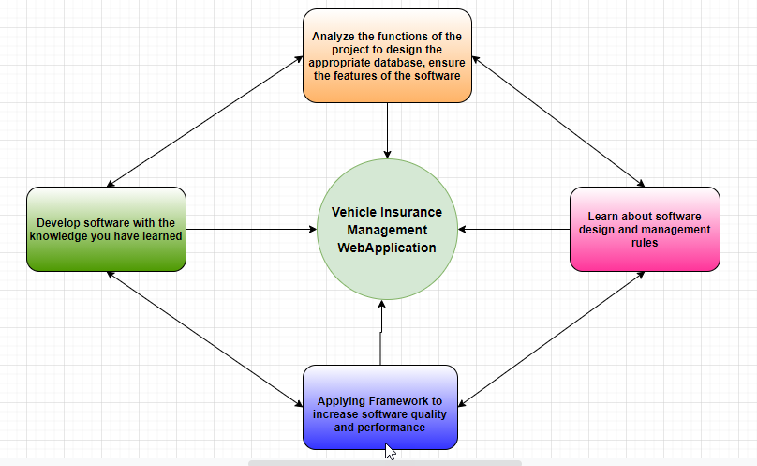

**IV . Project Design**

1. DFD (Data Flow Diagram)

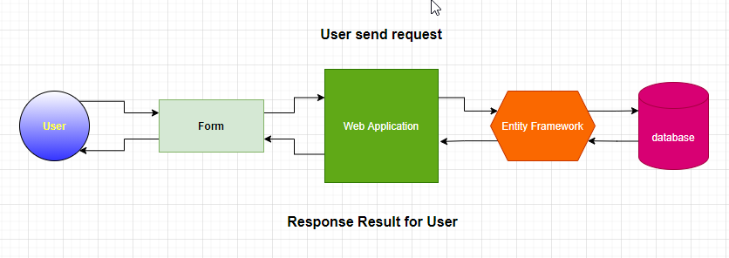

1. Flow Charts

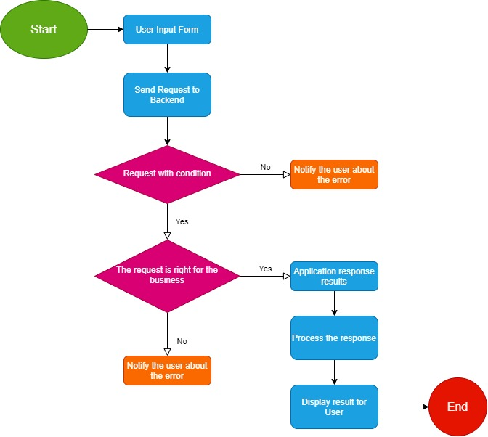

1. Process Diagram

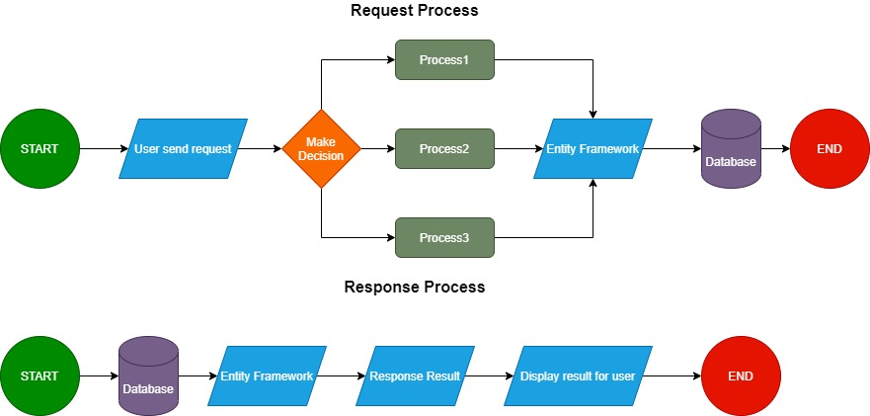

1. Database Design / Structure

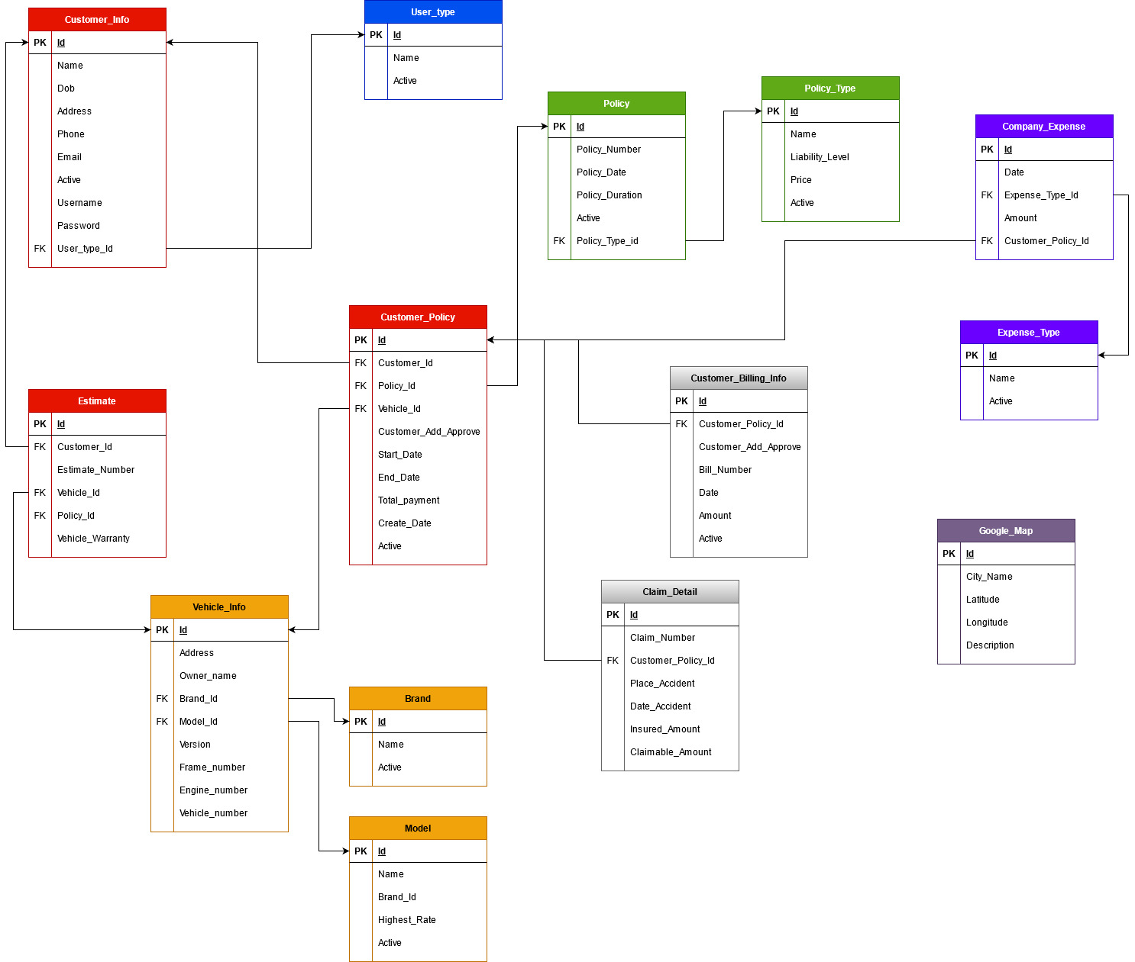

Detail Info: [Vehicle_Insurance_Management](https://docs.google.com/spreadsheets/d/180VbP5_NLKAUkPpnorwxnMYXUh7JobB3eePzA7HybCc/edit#gid=84062360)

**V . Screenshots**

1. **Authentication Module**

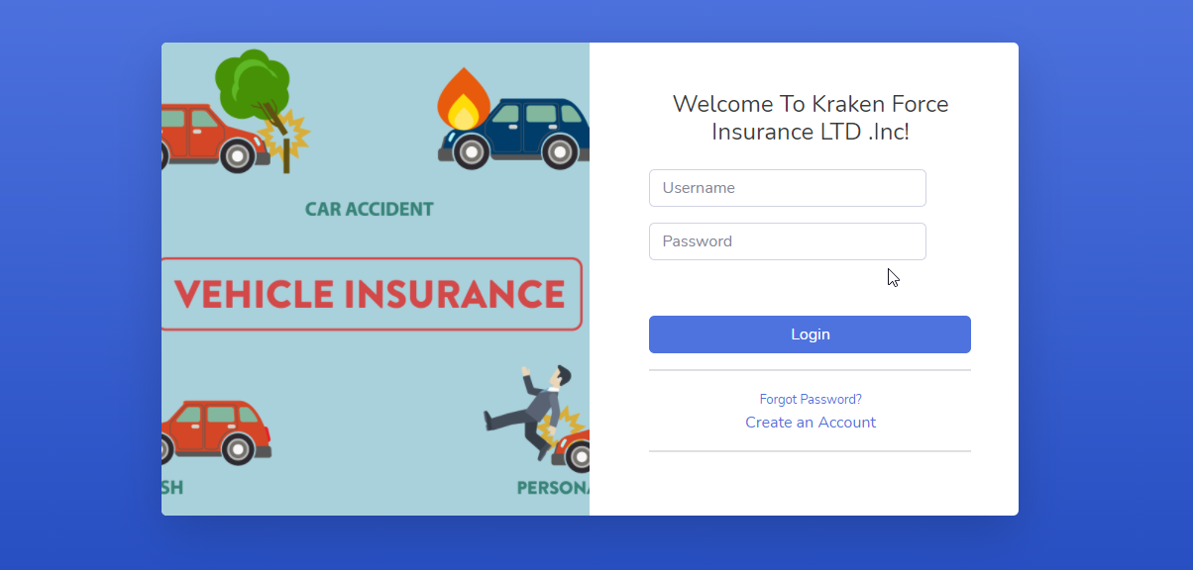

Login page

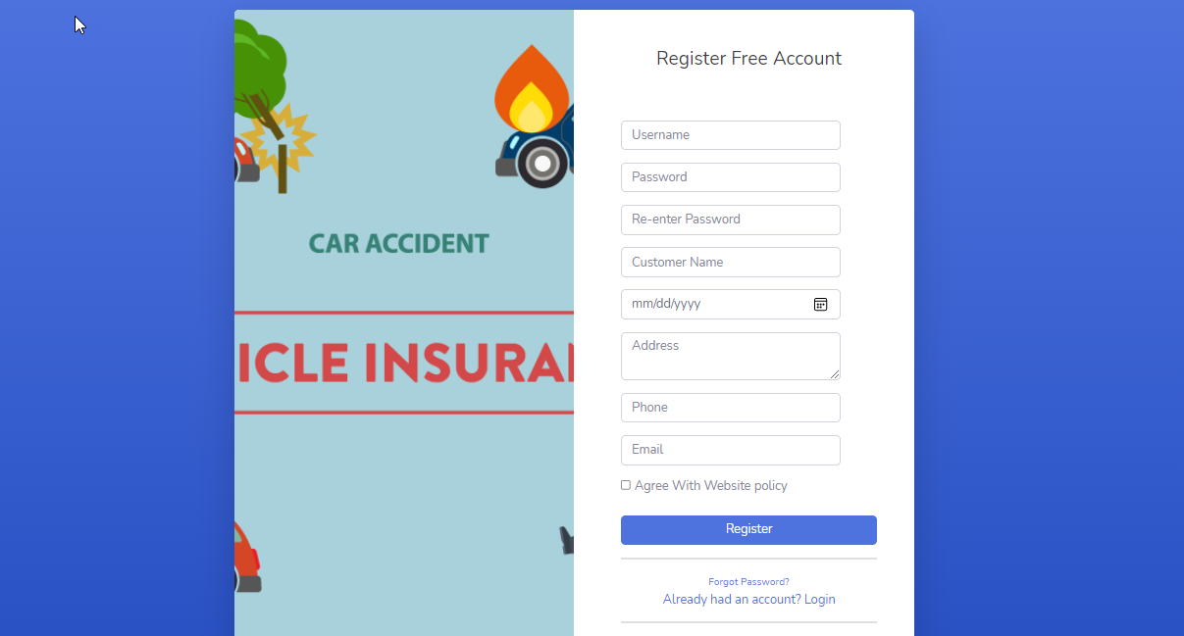

Register Page

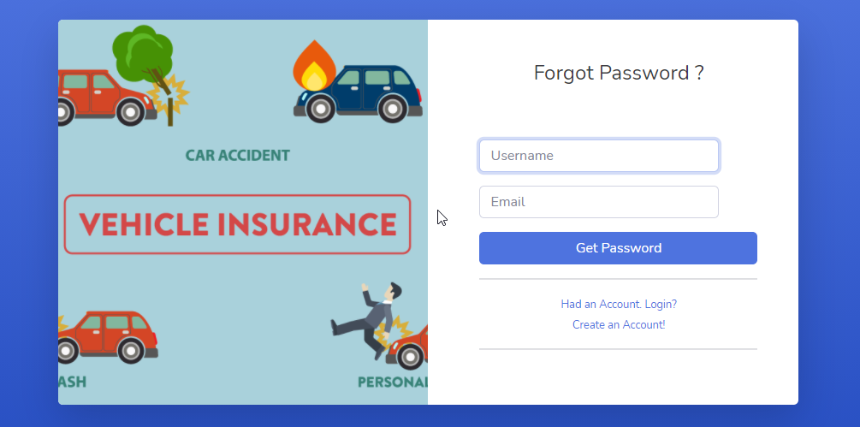

Forget Password Page

Login page

1. **Client Pages**

* **HomePage:**

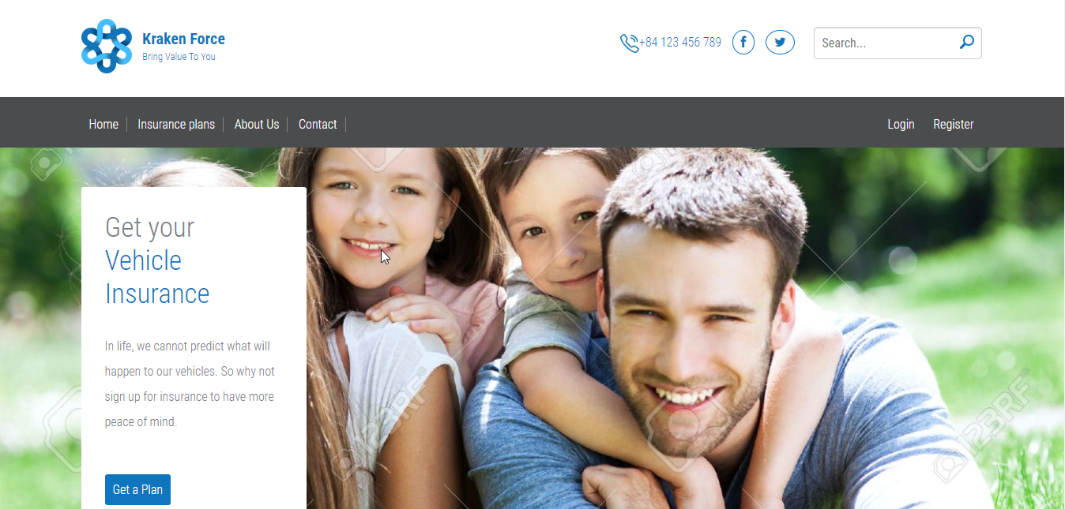

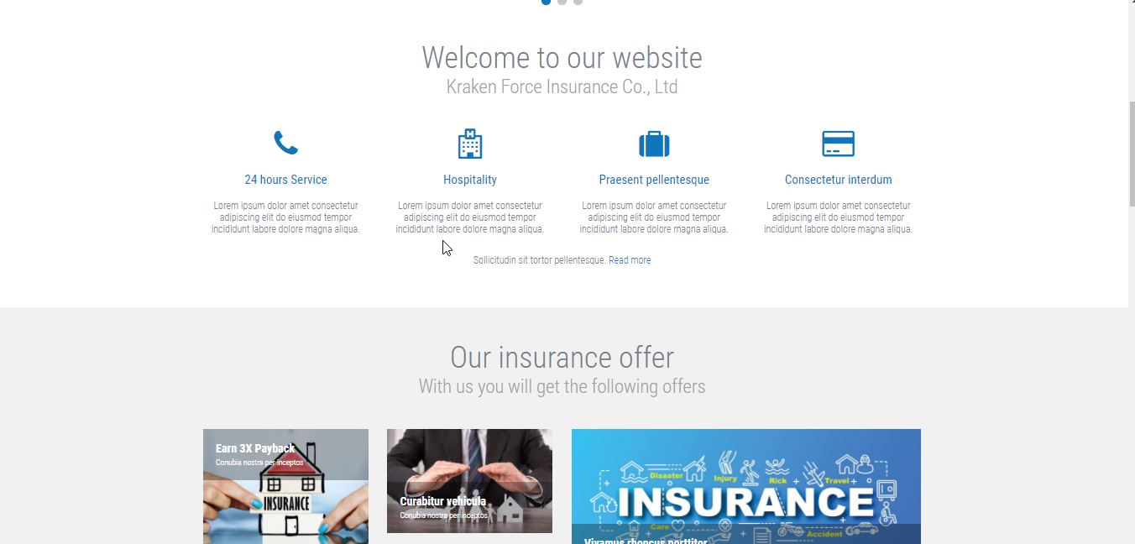

* **Insurance Plan:**

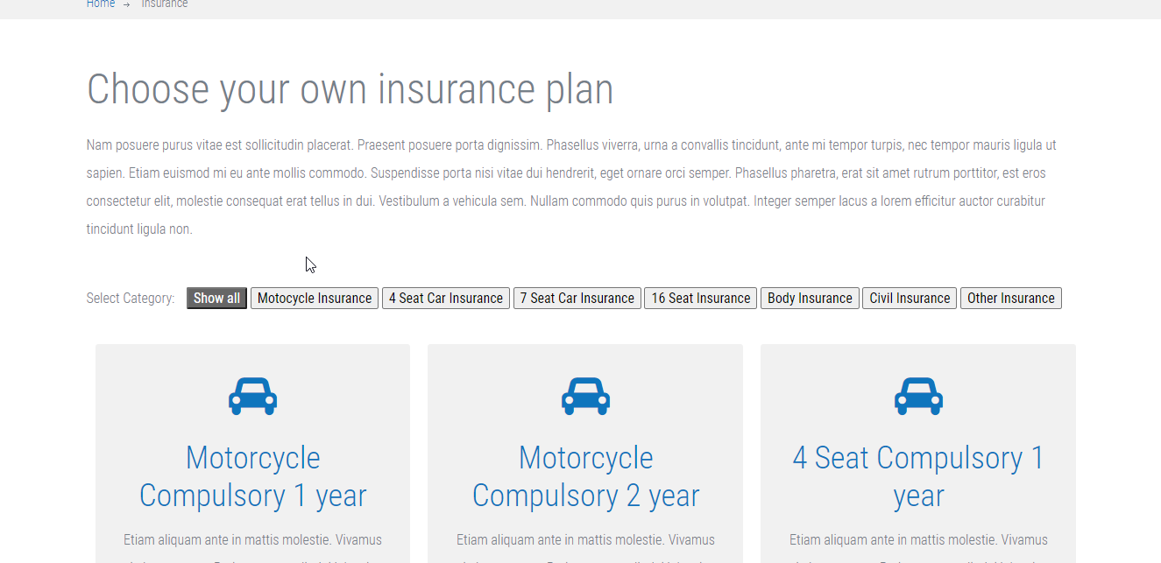

* **Contact:**

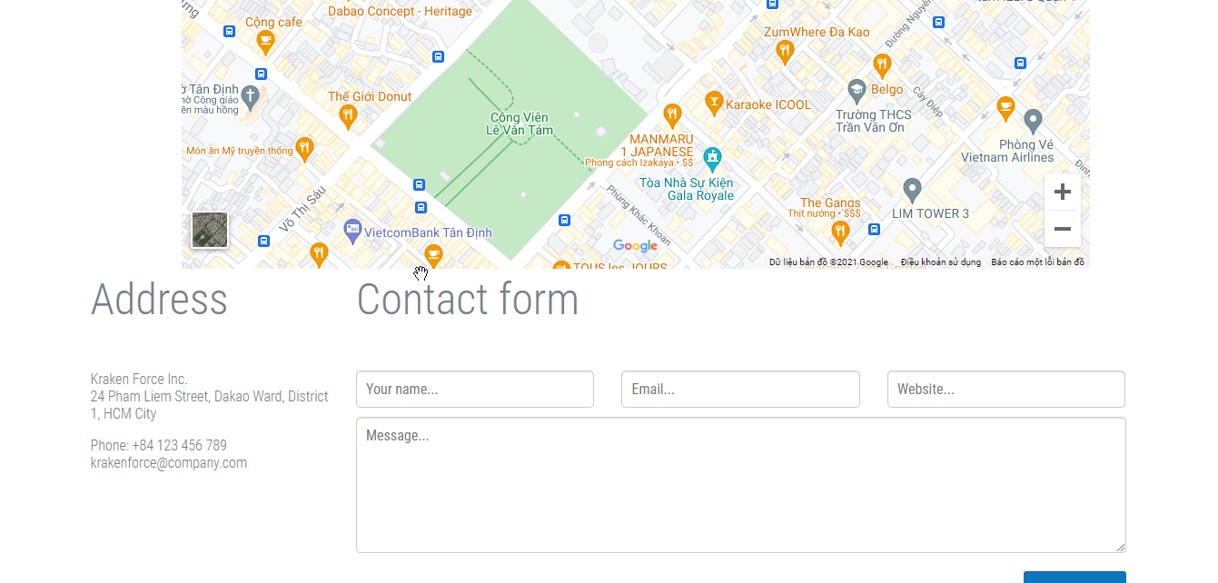

* **About Us:**

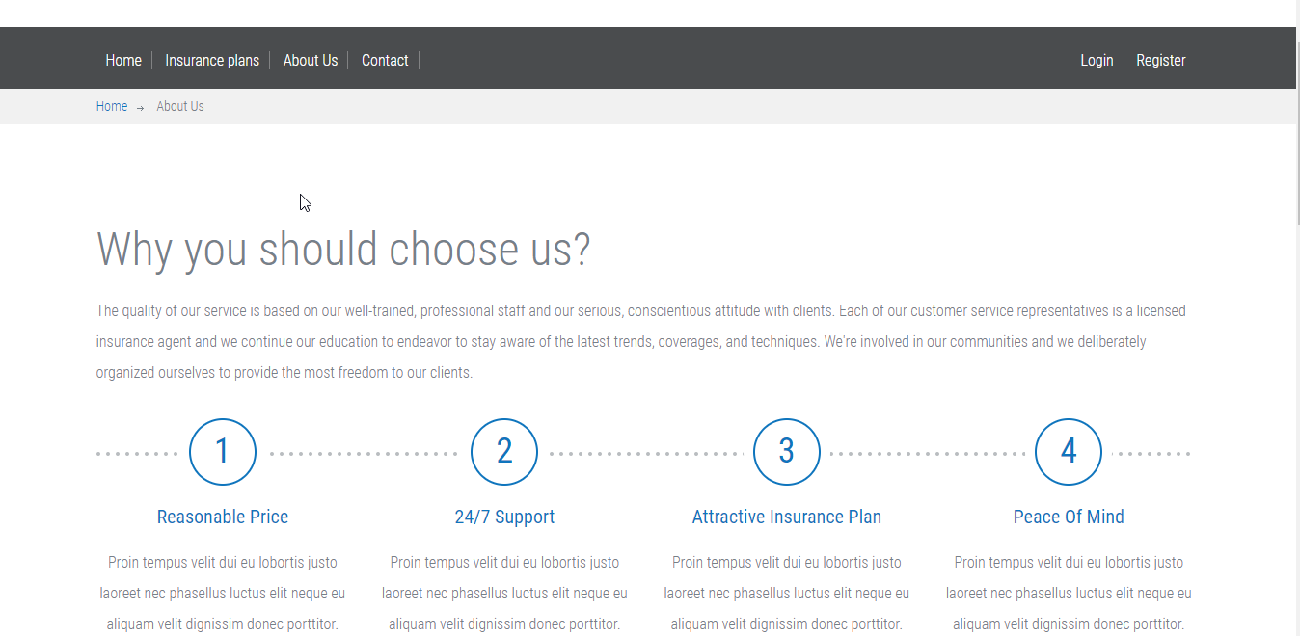

* **Customer History:**

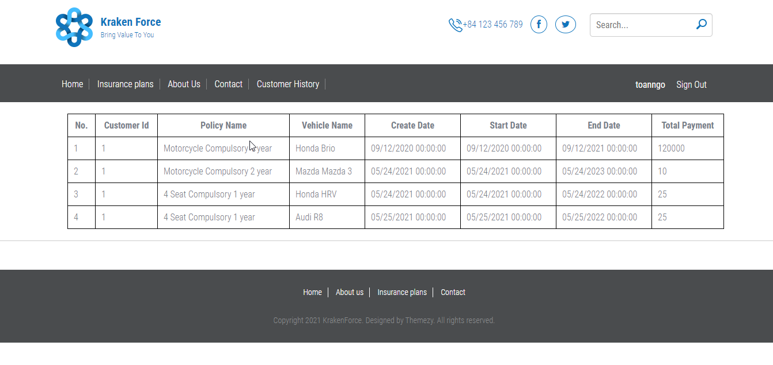

1. **Customer Manager**

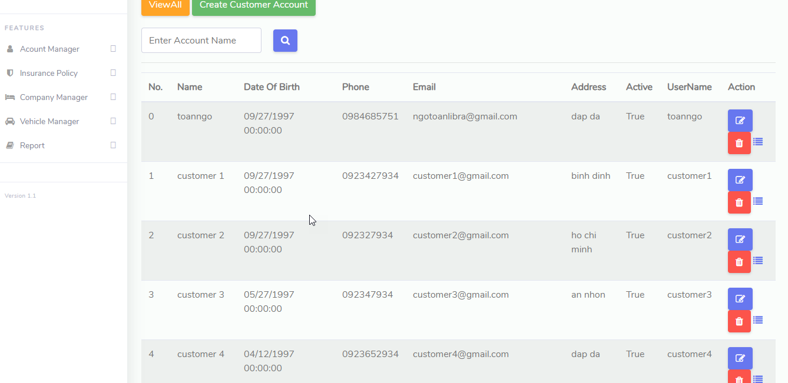

1. **Vehicle Info Manage**

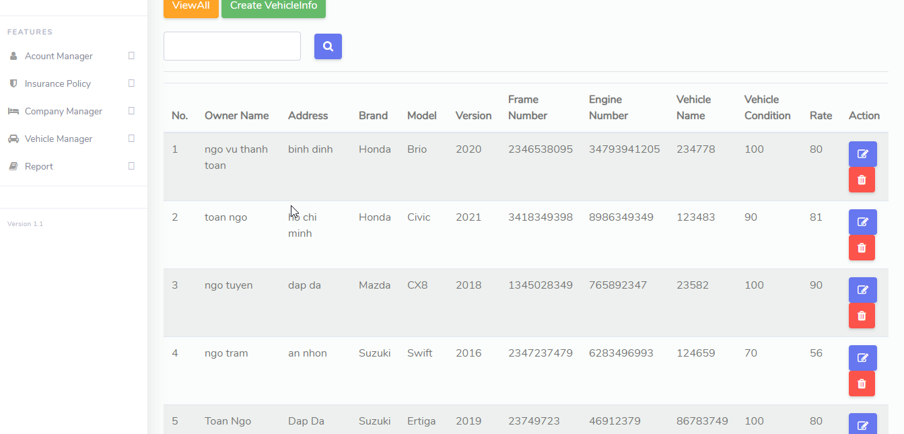

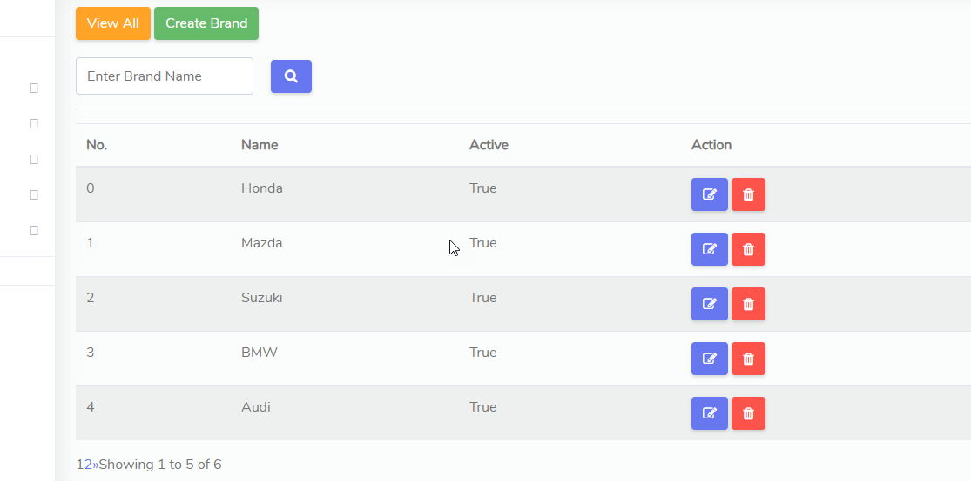

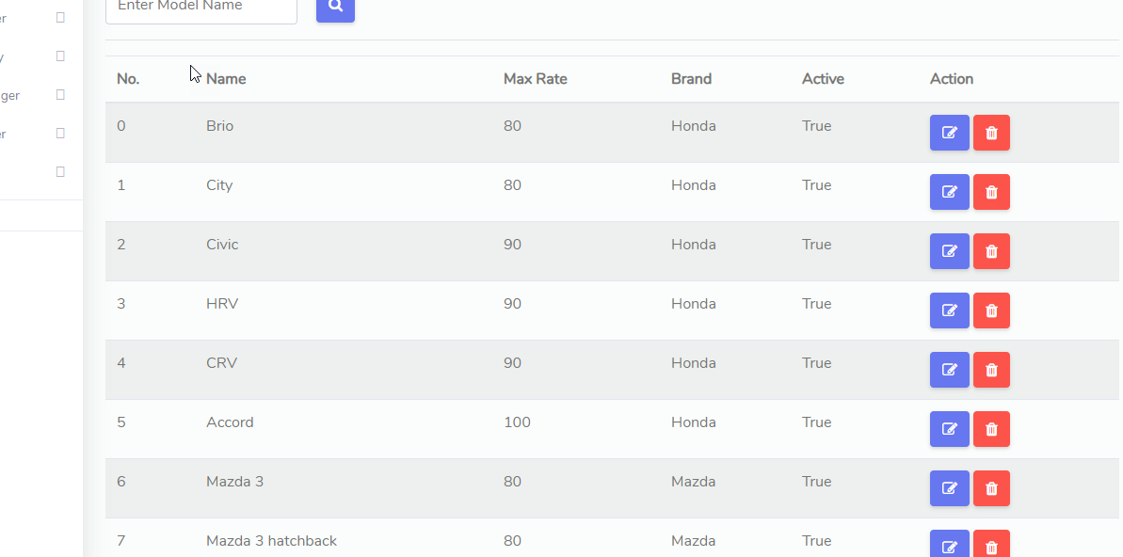

1. **Insurance Buy Module**

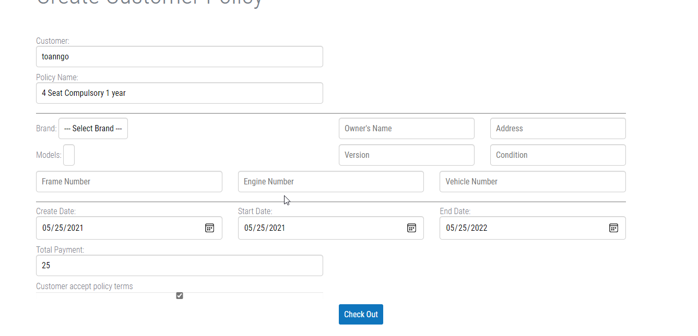

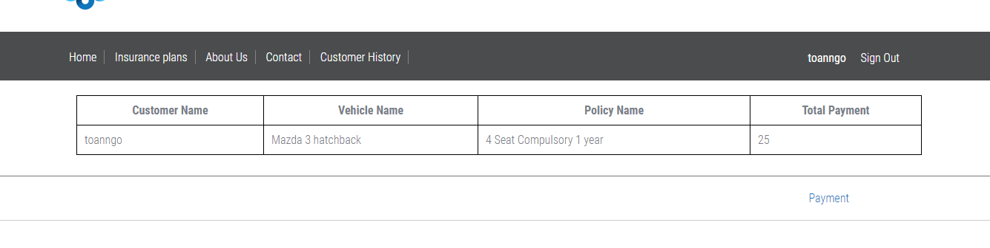

1. **Customer Policy Manage**

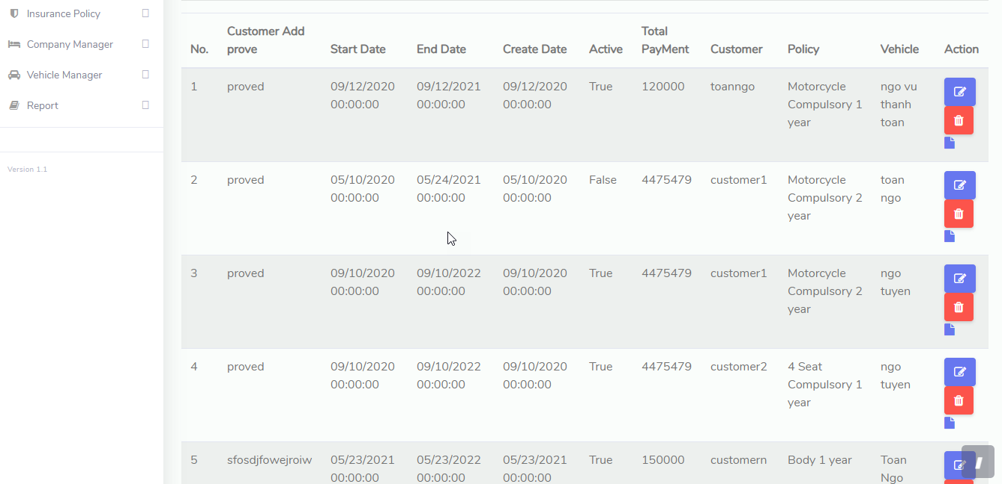

1. **Customer Policy Bill**

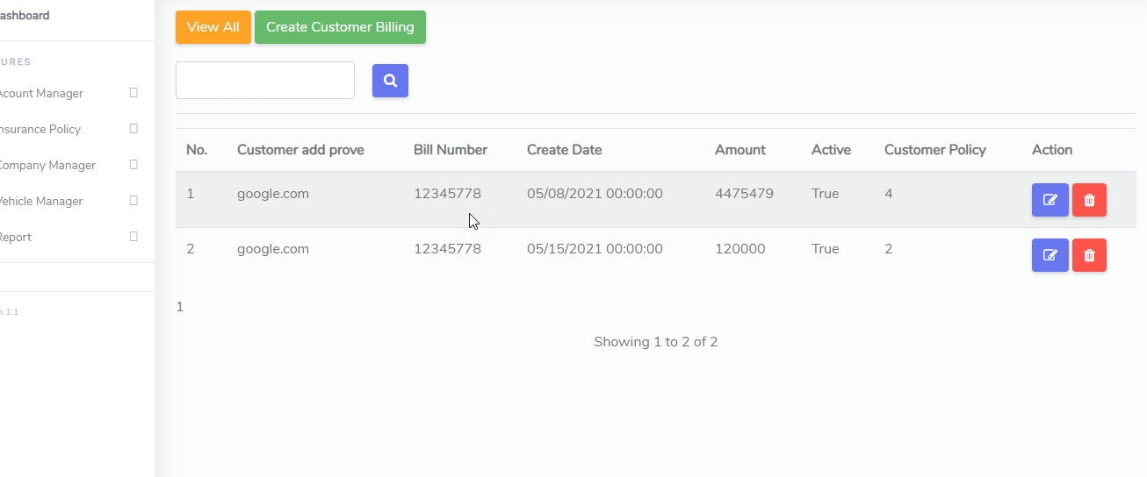

1. **Report**

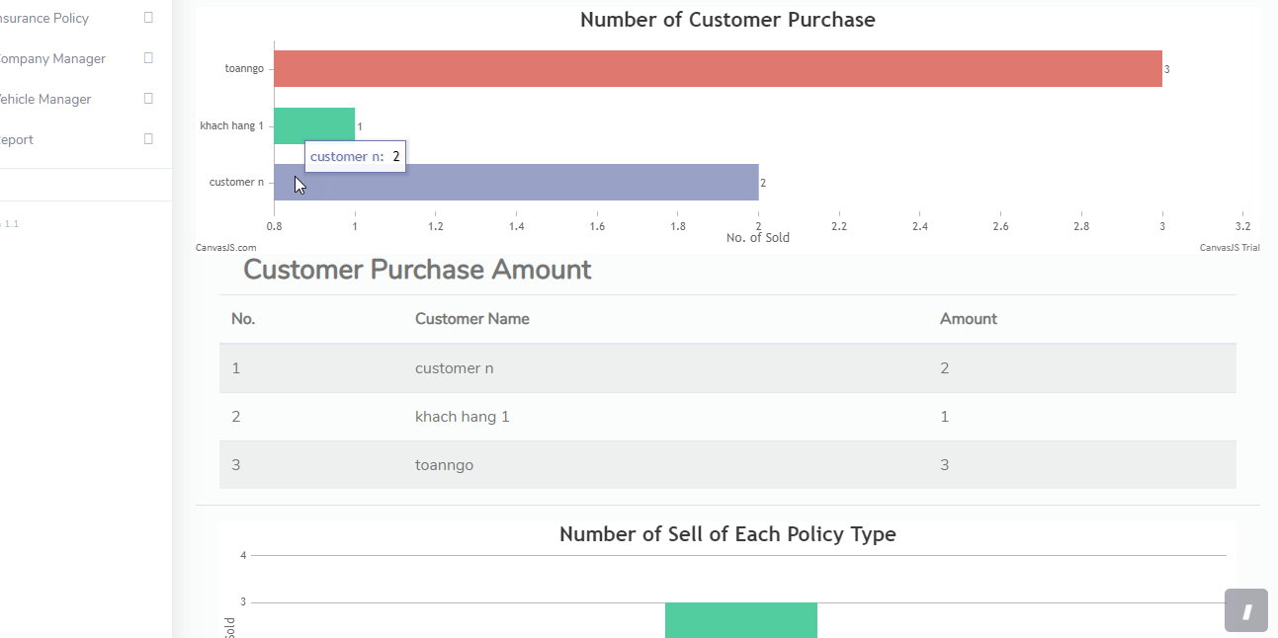

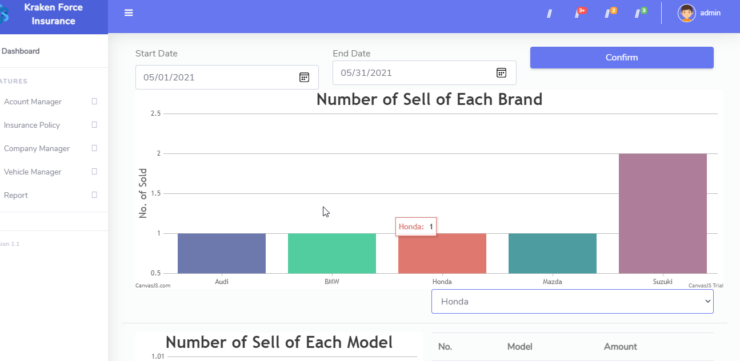

1. **Company Expense**

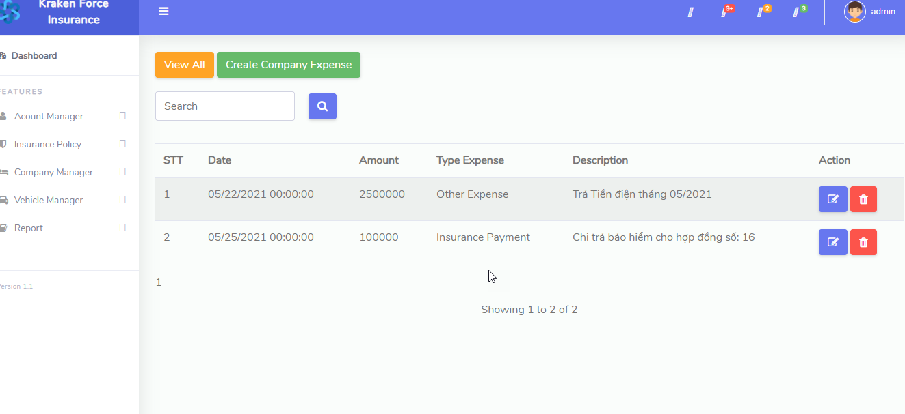

1. **Claim Detail Manage**

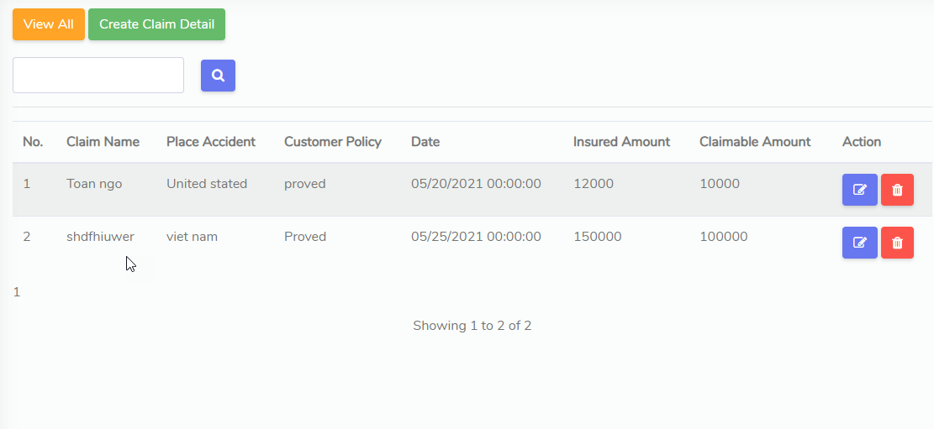

**VI . User Guide**

1. **Authentication**

* **Login**

To get started, click on Login if you want to login and Register if you want to register for a new account

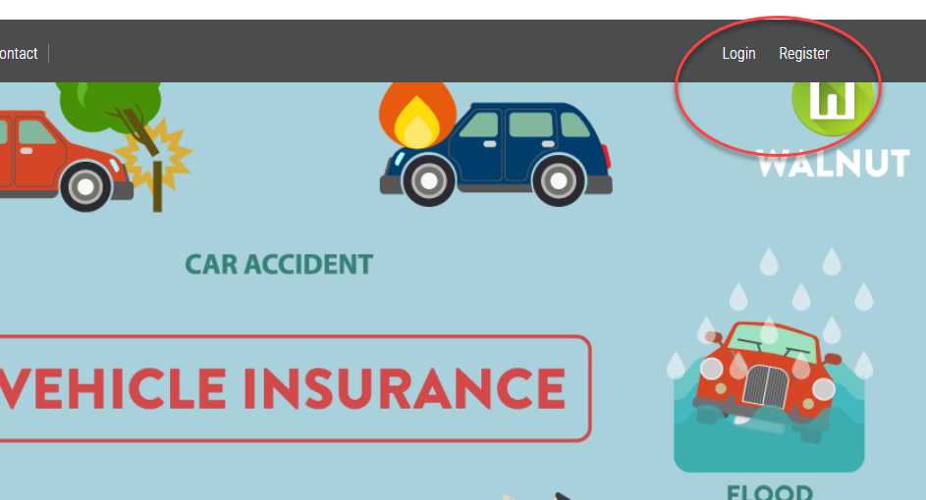

You will be redirected to the Login page

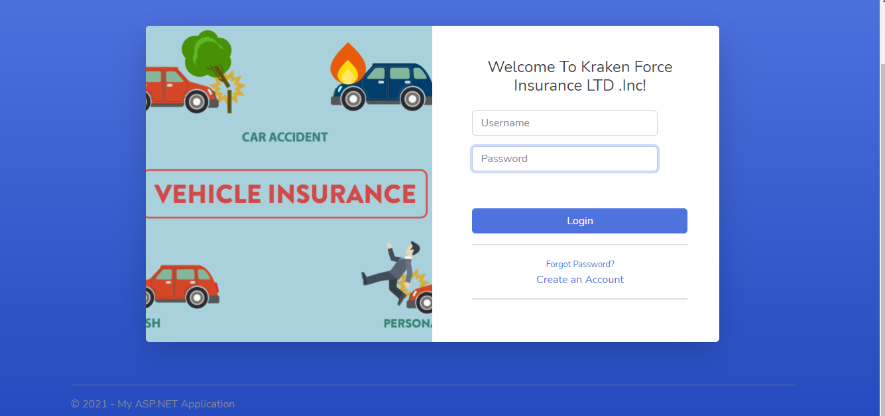

and the same goes for the Register page

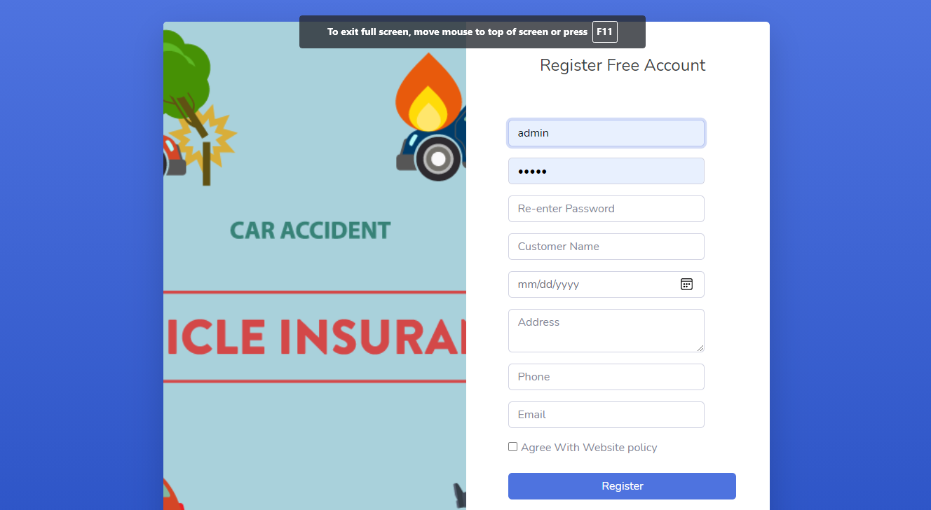

you can login with 2 types of users: Customer and Admin.

If you log in with customer account, you will be redirected to the HomePage

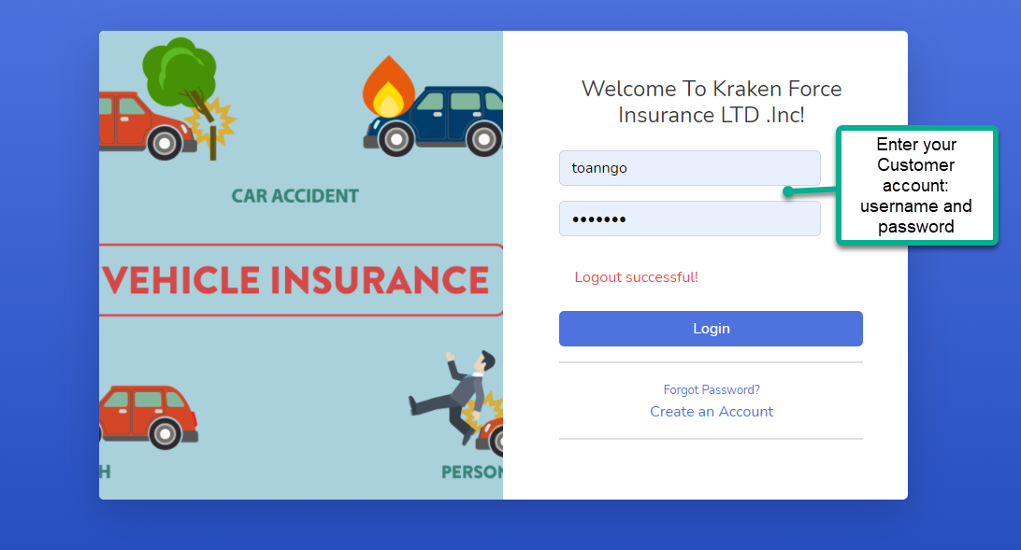

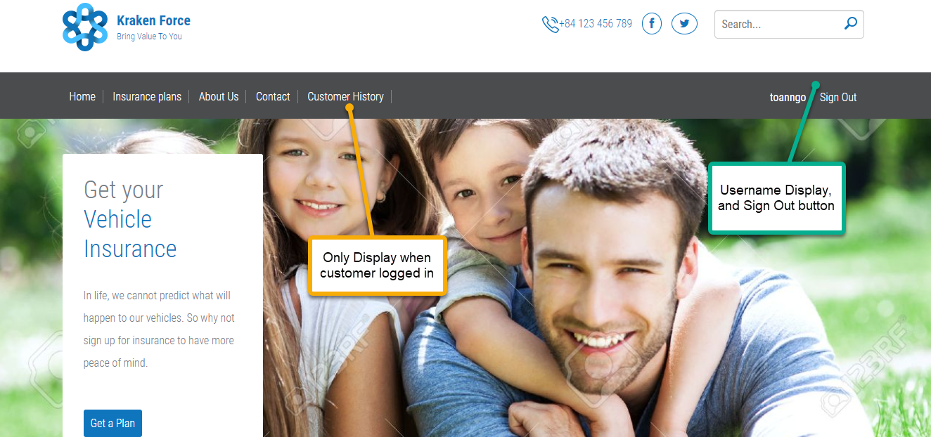

If you logged in with Admin account, you will be redirected to Admin’s Dashboard Page

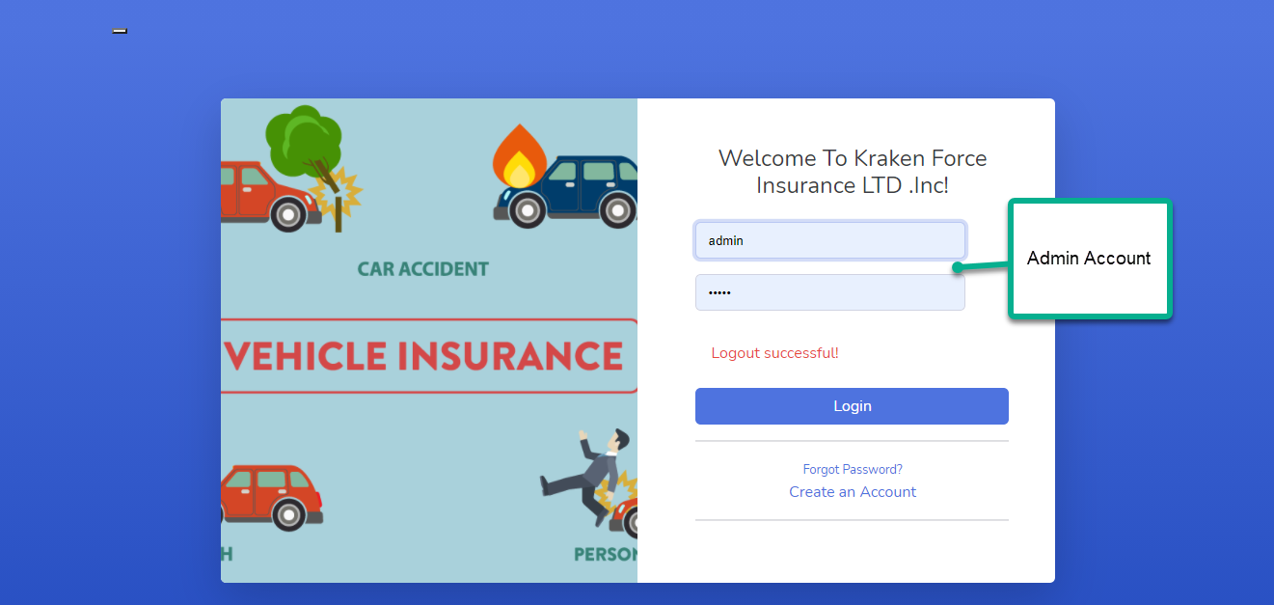

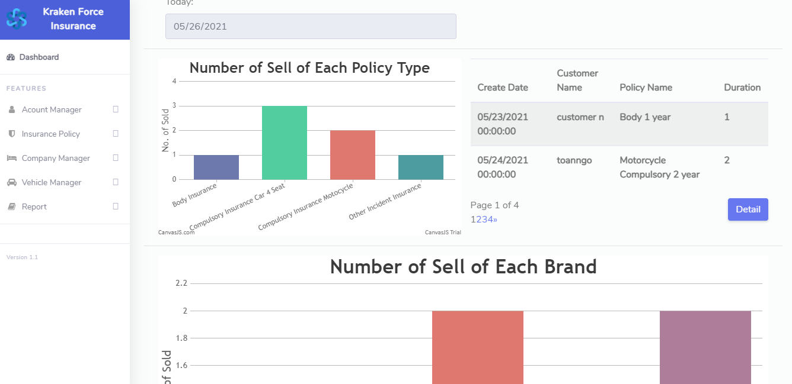

If you are unable to login, you should check the message on the Login page

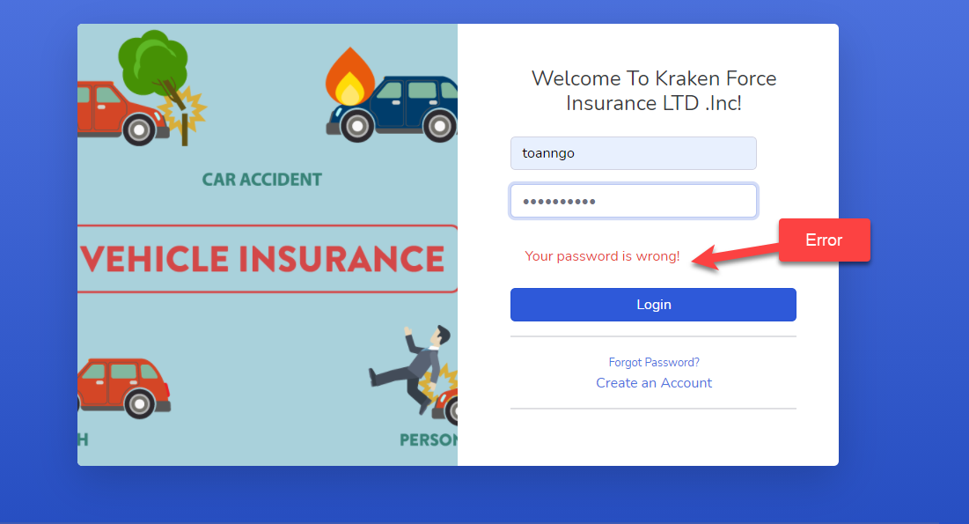

* **Register**:

To register a new customer account, enter the necessary information and then click the Register button

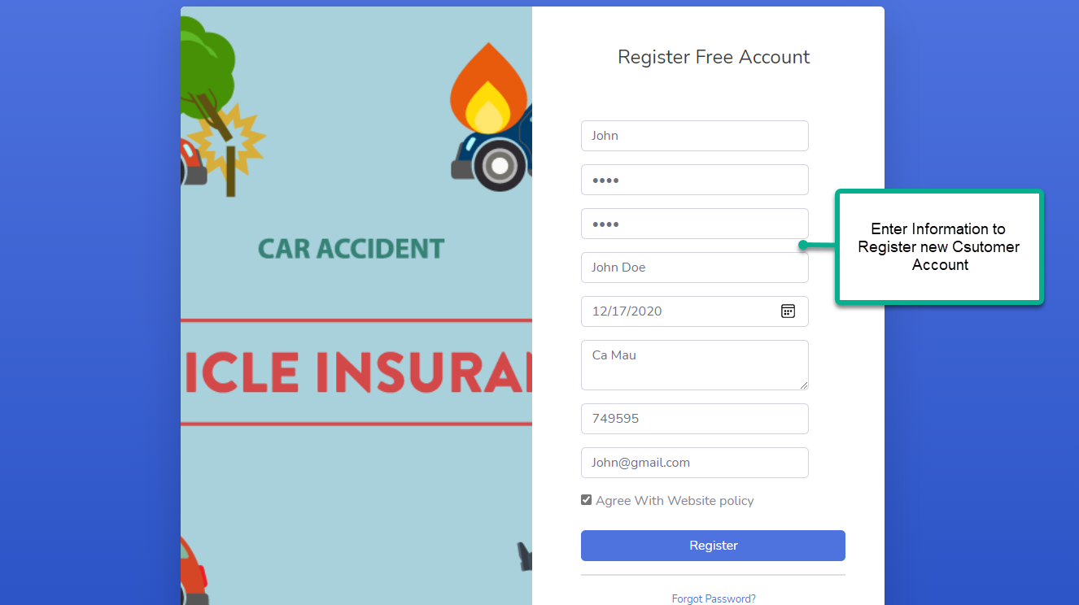

If the account registration is successful, you will be redirected to HomePage to log in.

If you can't register, error check is displayed

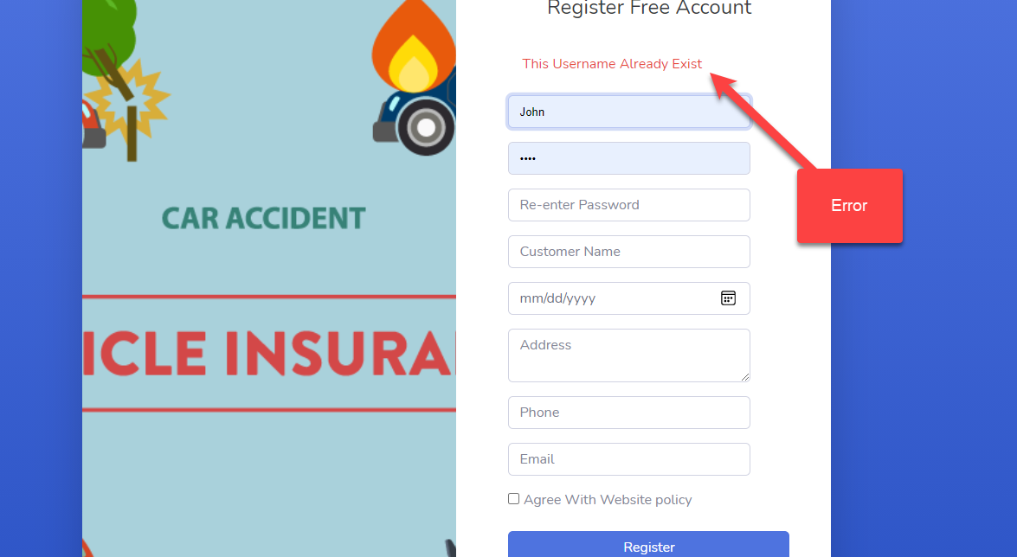

* **Forget Password:**

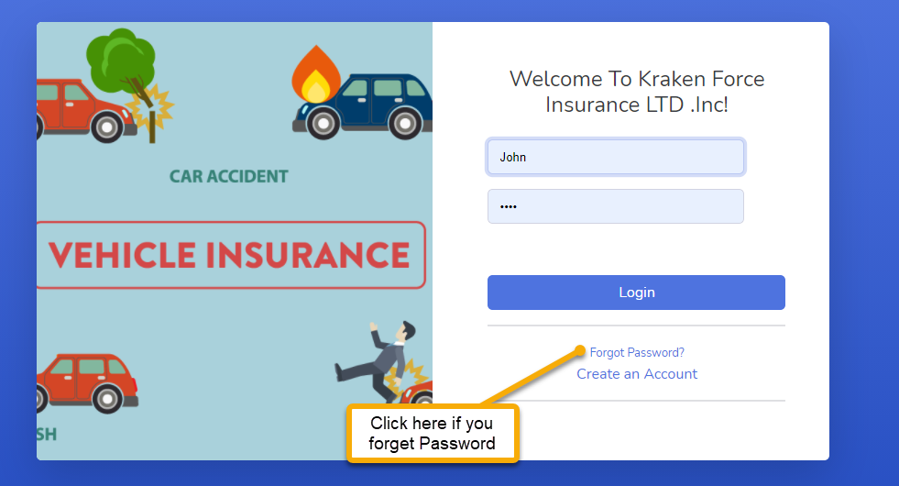

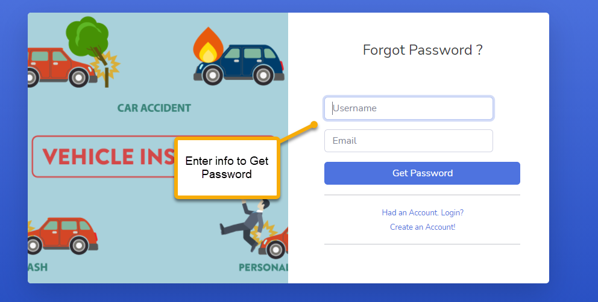

Please make sure that the email you entered is the same as the one you entered when you registered and is the real one because the password will be sent by Google Mail.

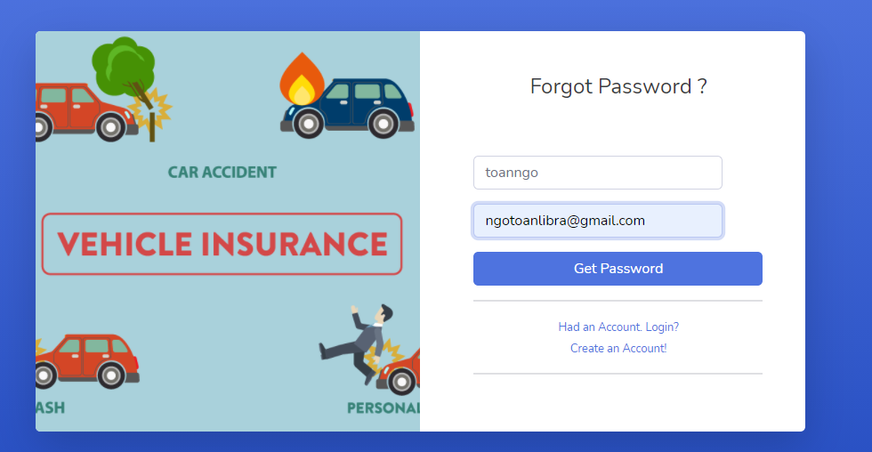

You will get a message like below, check your google mail to get the password

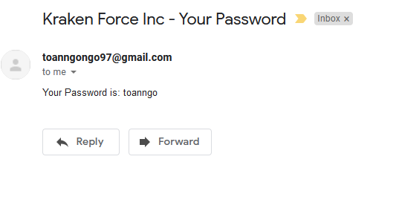

* **Change Password:**

To change the password, after logging in, hover over the username, from which the Change the Password section will appear. Click in

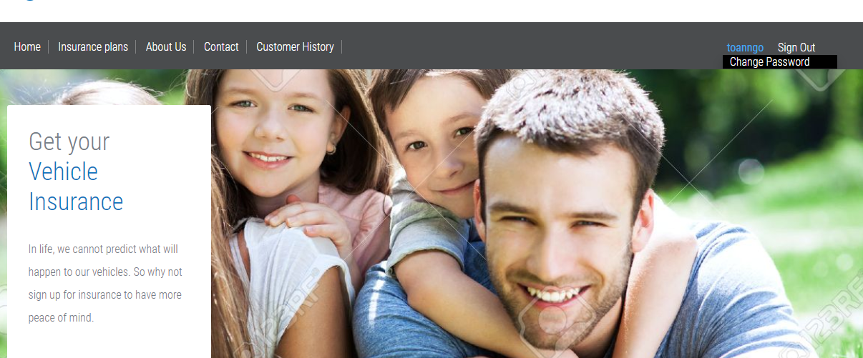

You will be redirected to the Change the Password page. Enter the correct information to change the password

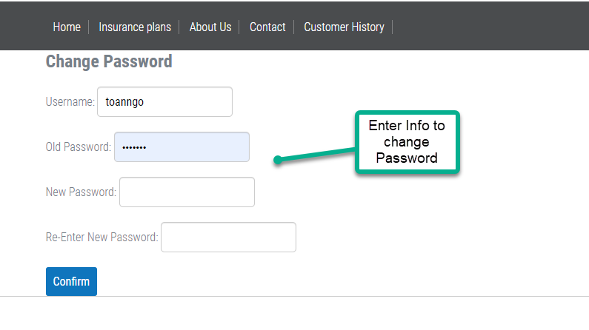

1. **Client Pages**

* **Home**

On the Homepage, you can see some information about the website, news and other things

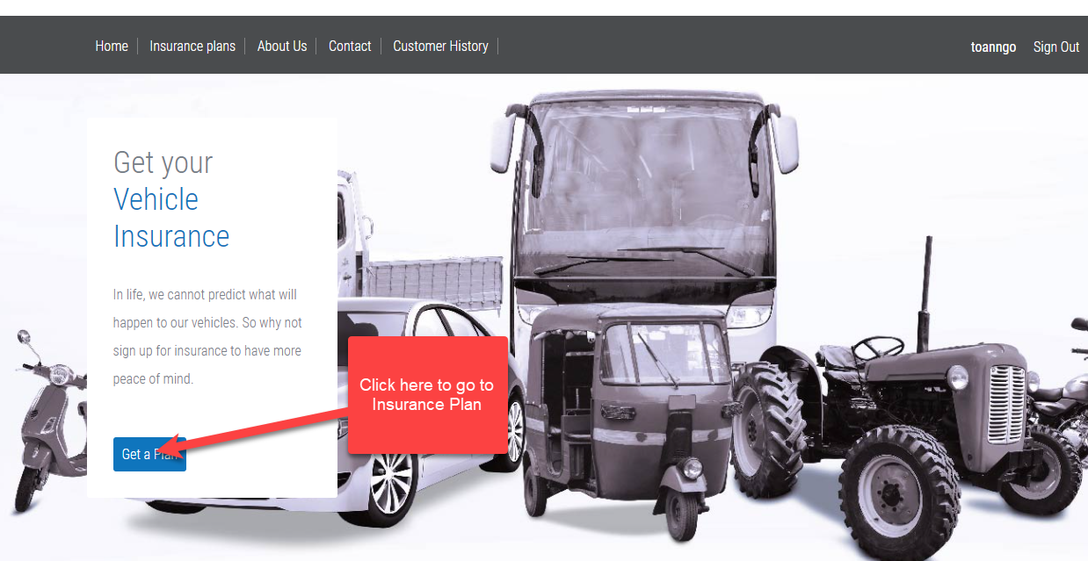

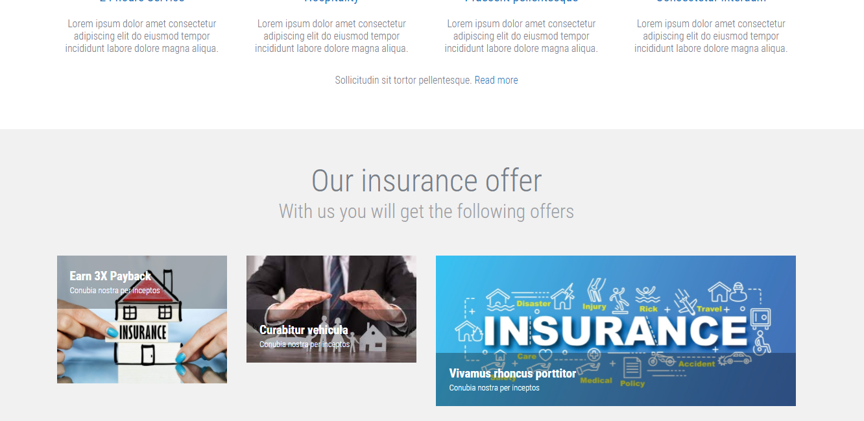

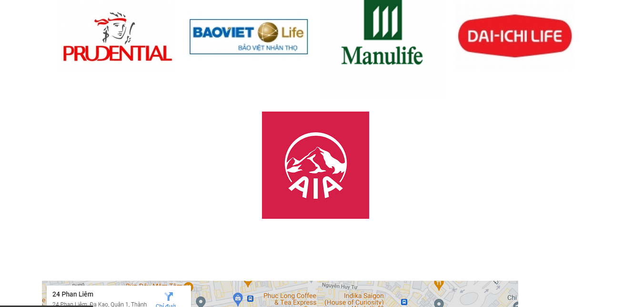

* **Insurance Plan**

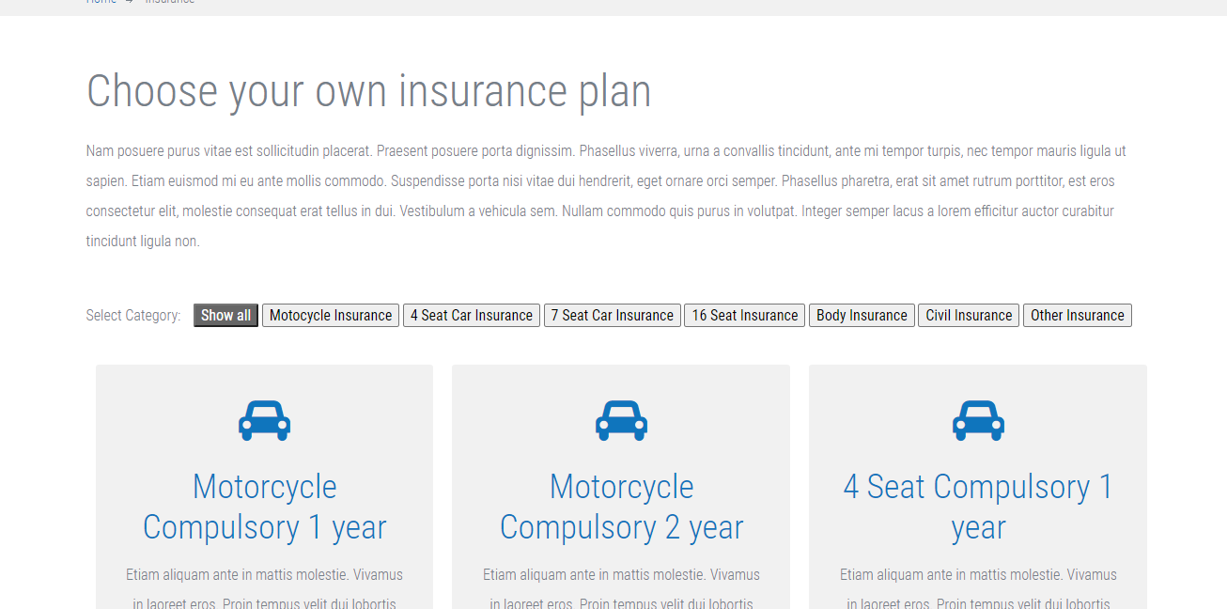

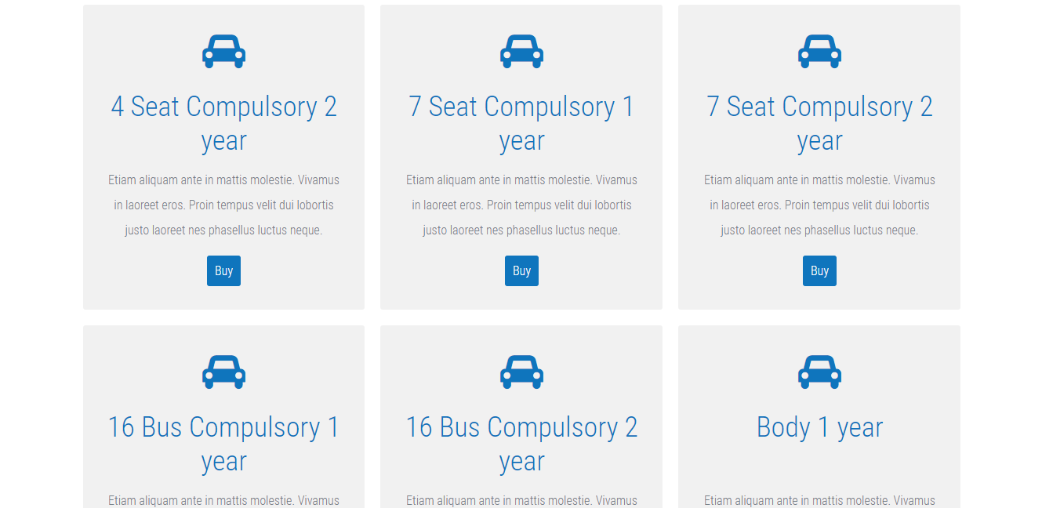

if you want to see the insurance plans by type, select as shown below, the insurance plans will be displayed accordingly

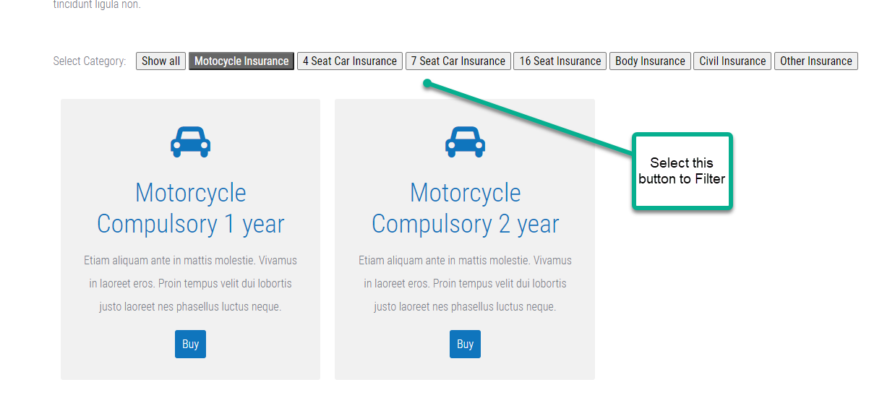

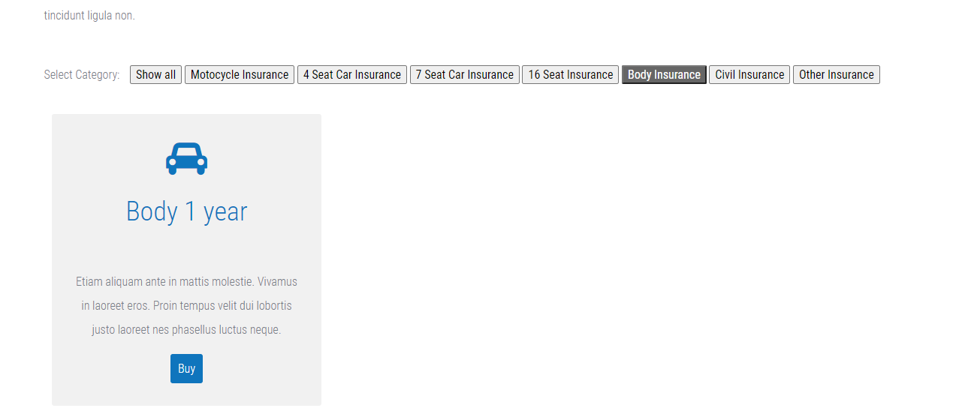

* **About Us**

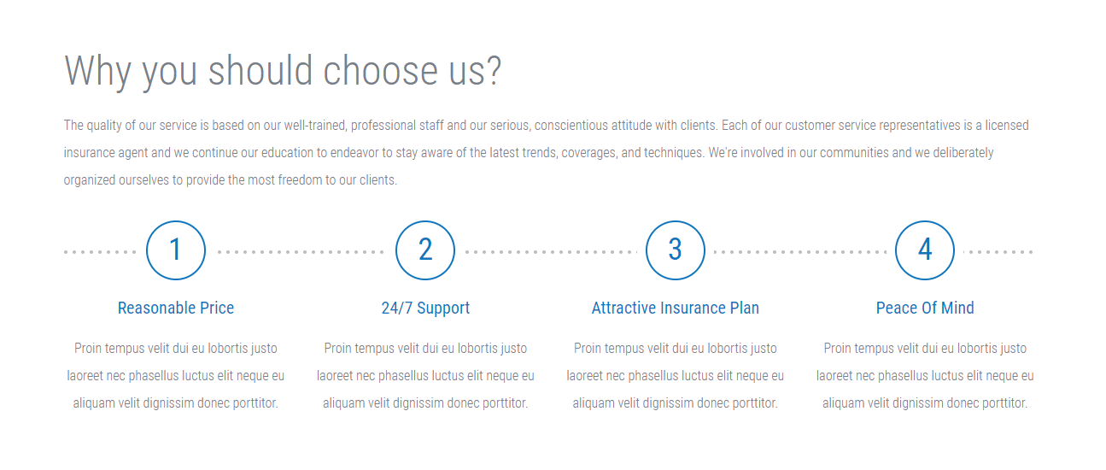

* **Contact**

You can enter contact information to contact us

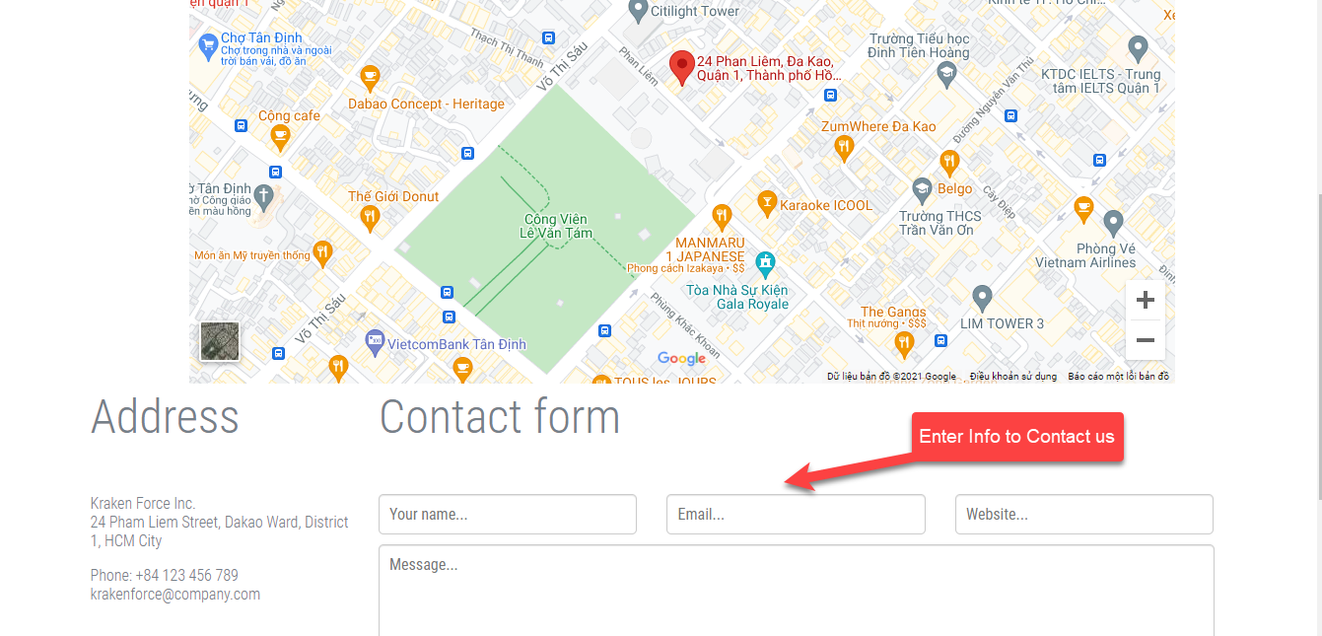

You can see the company address on the site map

* **Customer History**

With the customer history page, you can view your insurance purchase history including basic information

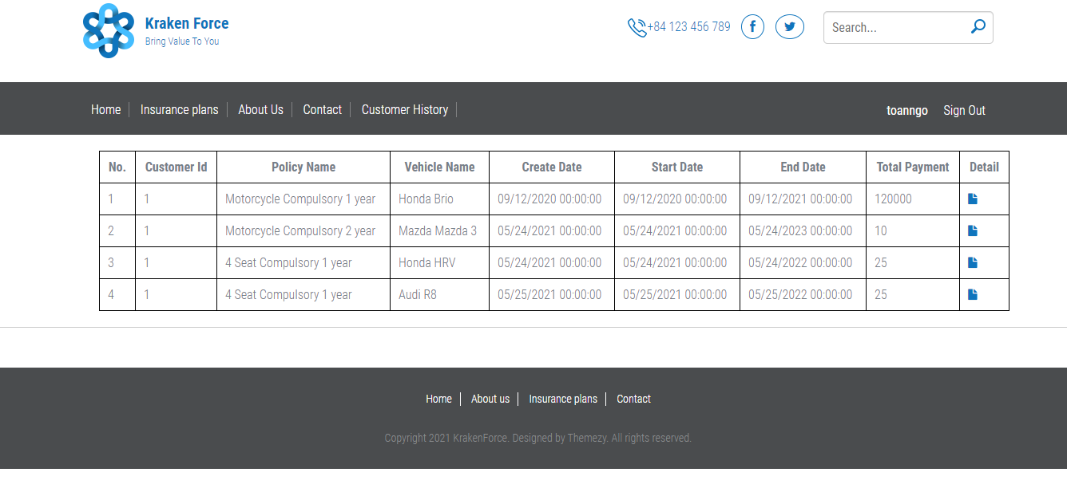

Click on icon to see detail of Customer Policy that you purchased

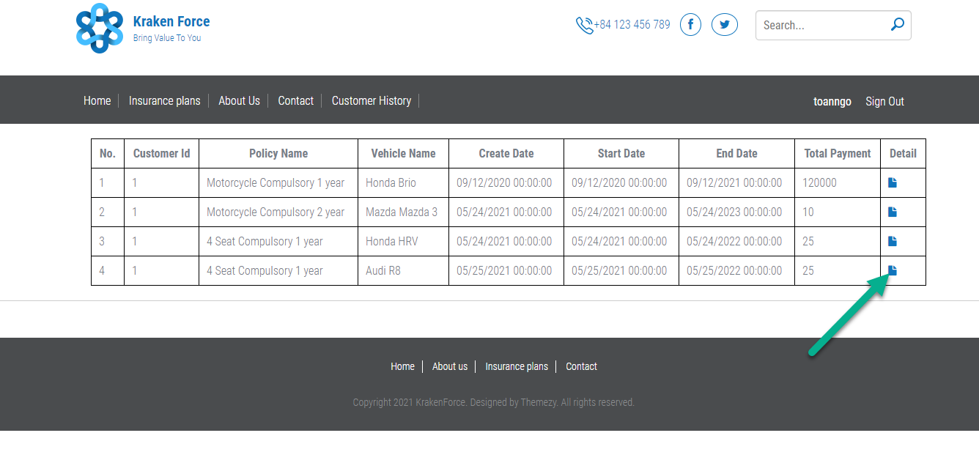

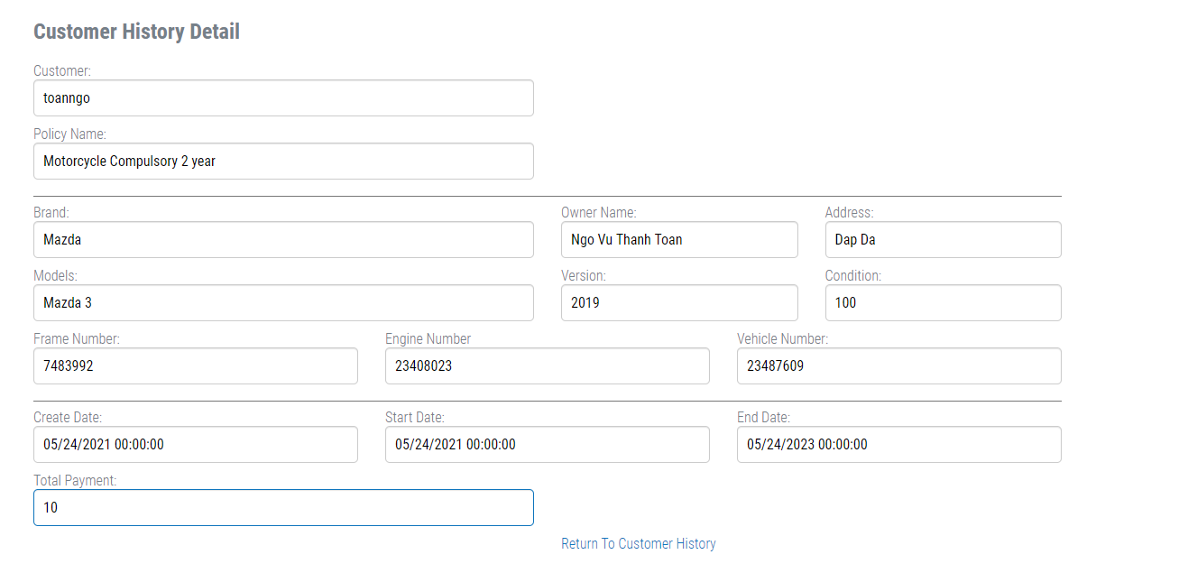

1. **Customer Manage**

* Account Manage

Select Account Manager on the left side of the screen, then select Account to enter the customer account information management page

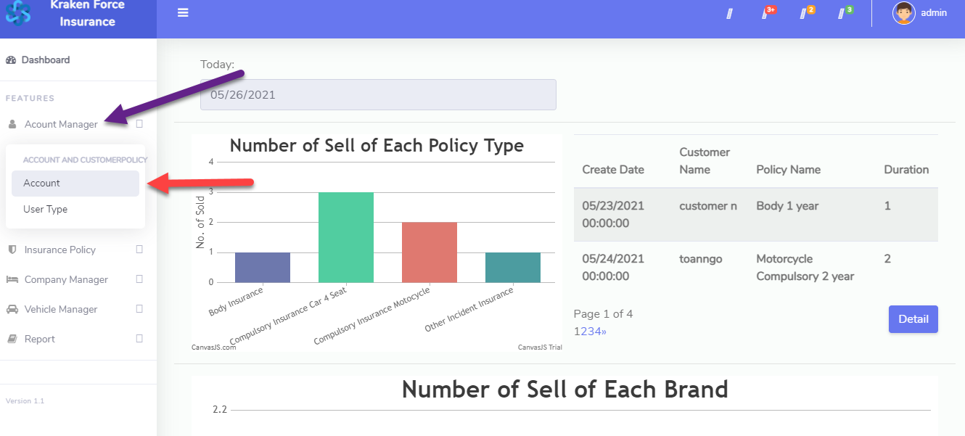

Click ViewAll to see all account, enter username into search field and click Search Button to see account, click on Edit or Delete button to edit and delete account, click on icon on the right to see all Customer Policy of Customer Account

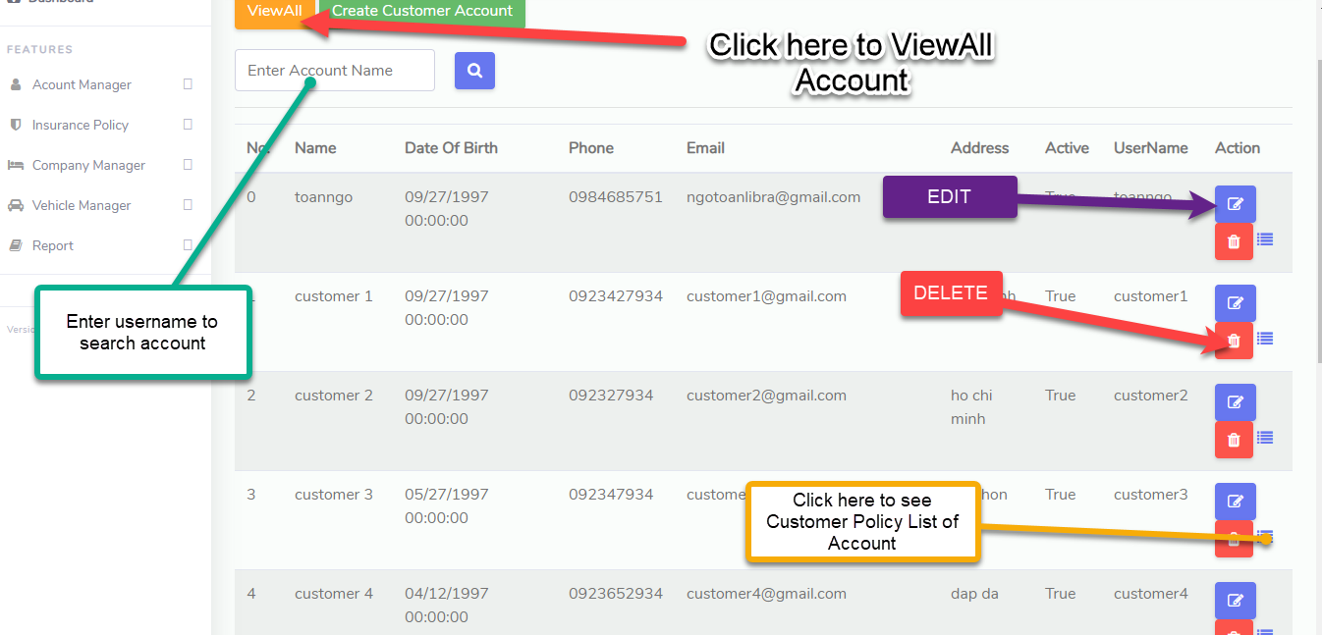

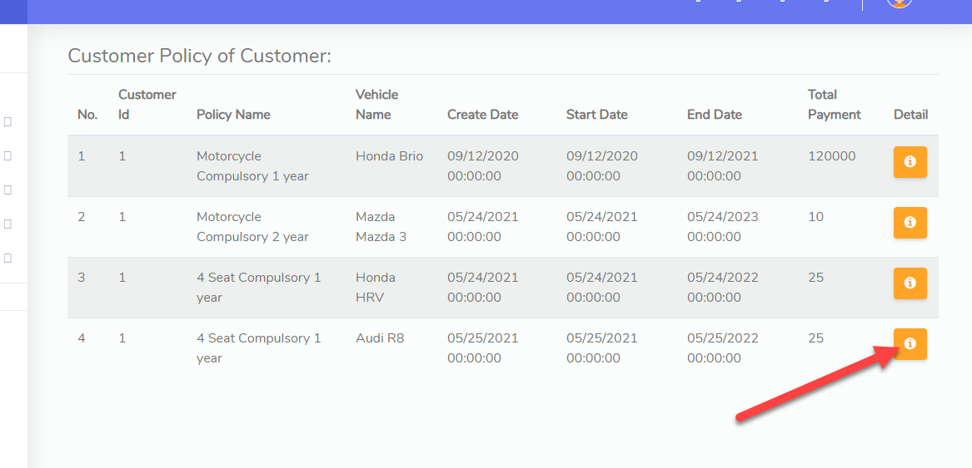

Click on Info icon to see Detail of that Customer Policy

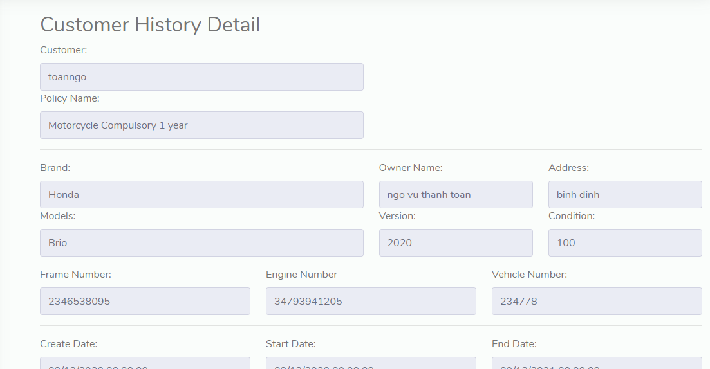

* User Type Manage

Click on Account Manager and choose User Type to go to User Type Manage

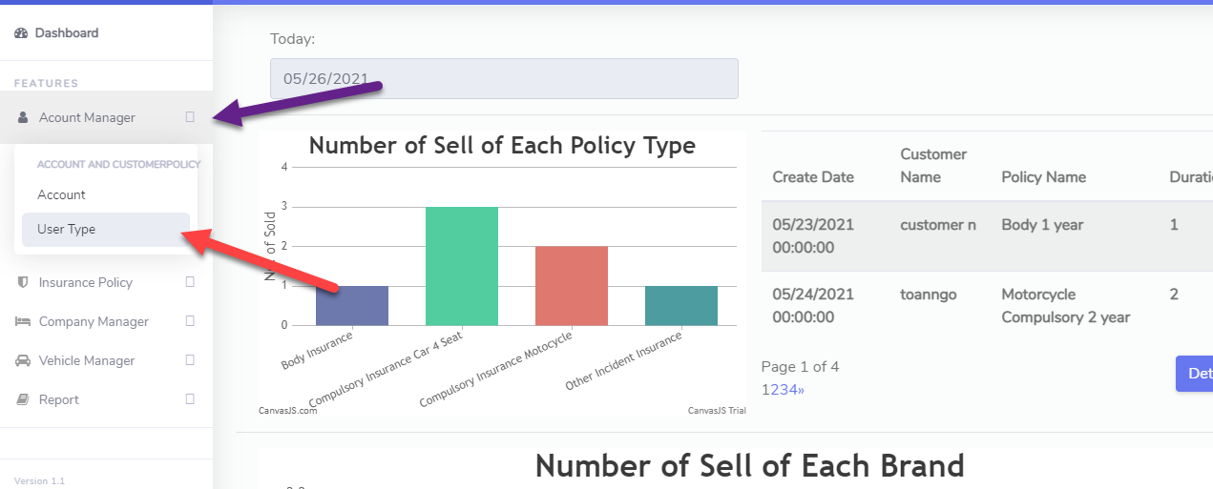

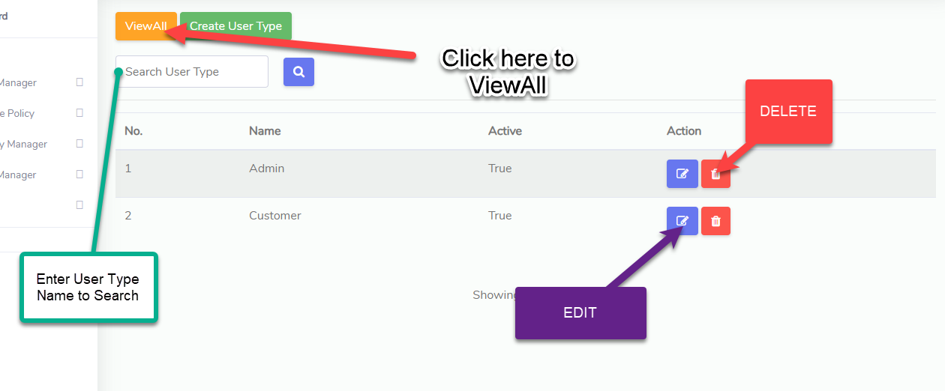

1. **Vehicle Manage**

* Vehicle Info:

Click on Vehicle Manager Tab and Select Vehicle Info to go to Vehicle Info Page

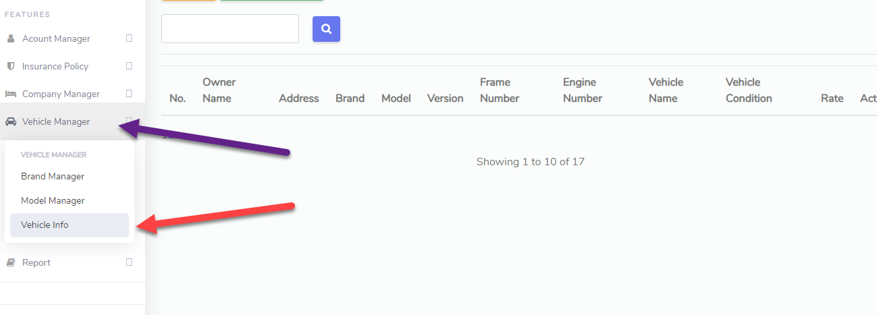

Select **ViewAll** to see all Vehicles, vehicle will be generated when the user buys insurance, click **Edit**(blue icon) to edit vehicle info, click Delete(red icon) to delete the vehicle.

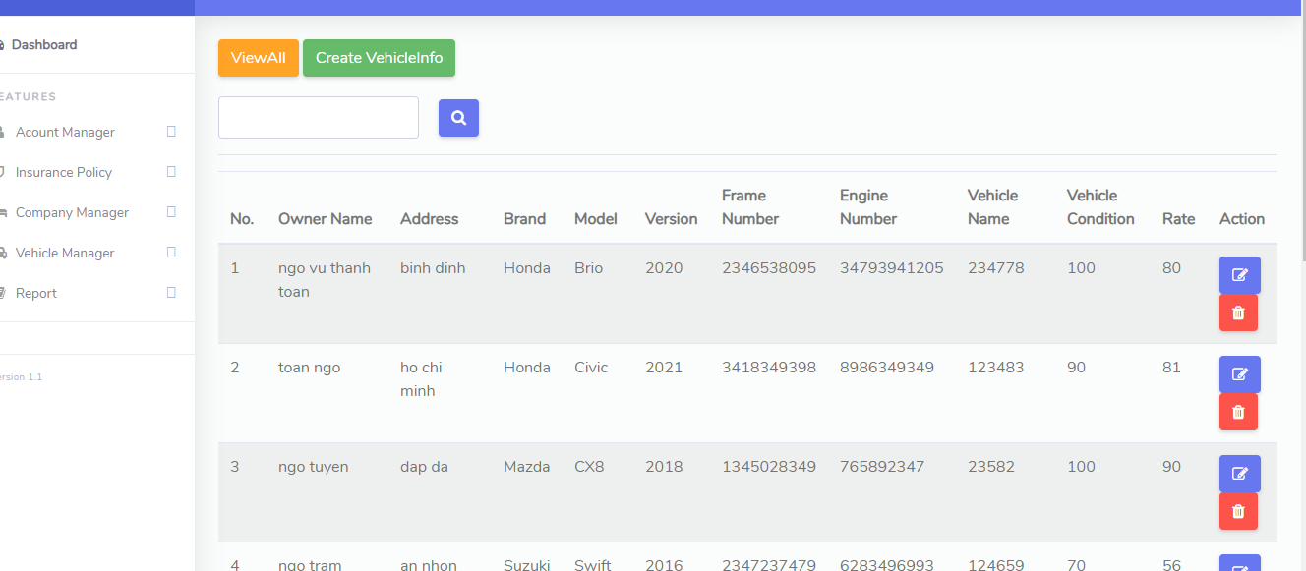

* Brand Manage:

Select Vehicle Manager tab and select to Brand Manager to go to Brand Manager Page

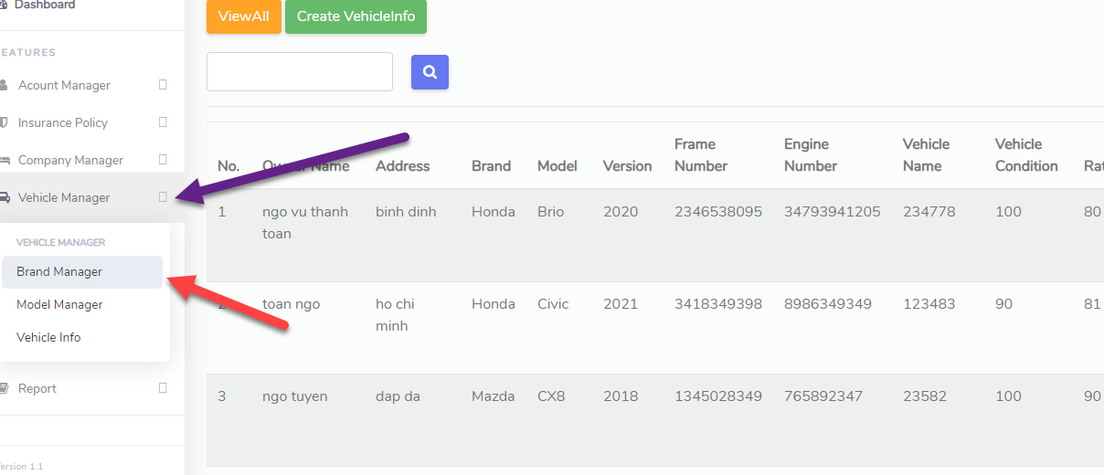

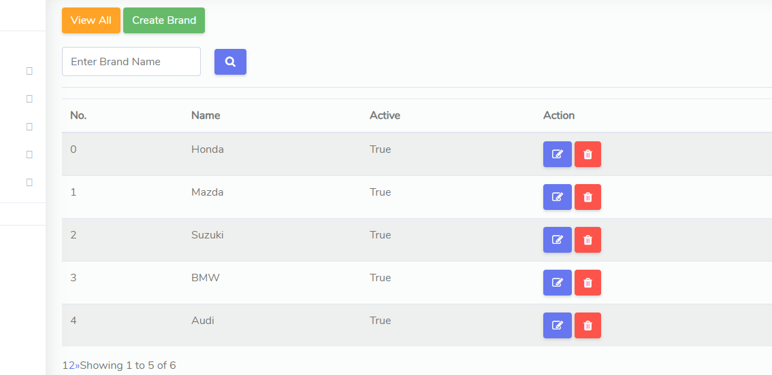

Click View All to see all Brand . Click to Create Brand to create new Brand

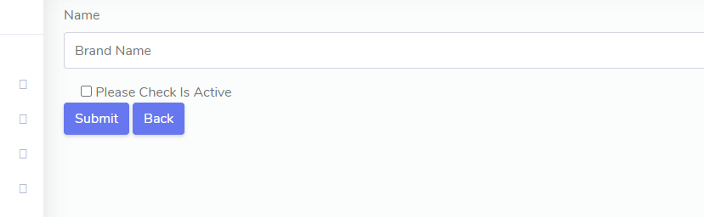

Enter Brand name, check to active and click on Submit Button to add Brand.

* Model Manage:

Click on Vehicle Manage tab and select Model Manager to go to Model Manager Page

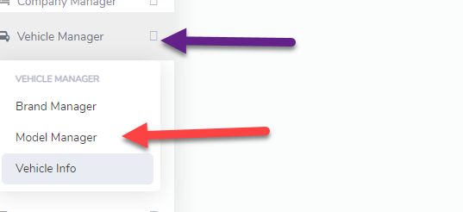

Click on **View All** to see all Model, enter model name to search box and click button to search model. If You want to create new Model, select **Create Model** button

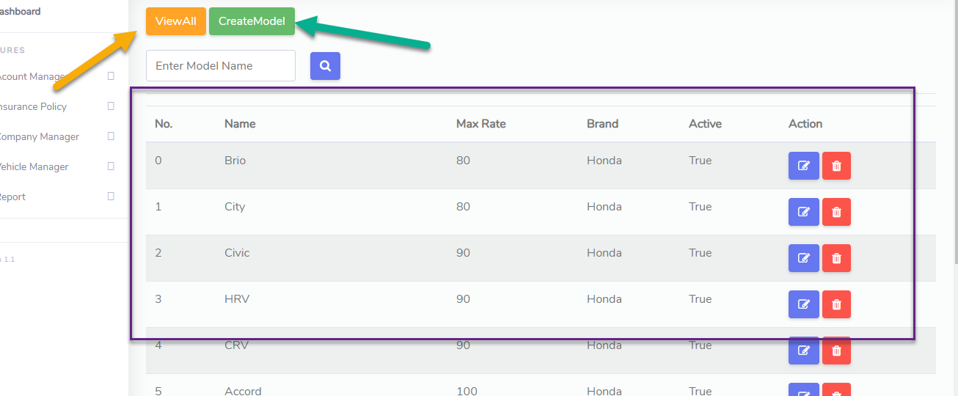

Enter Model name, Max Rate( model's maximum compensation percentage used to calculate compensation) and select Brand that Model belongs to

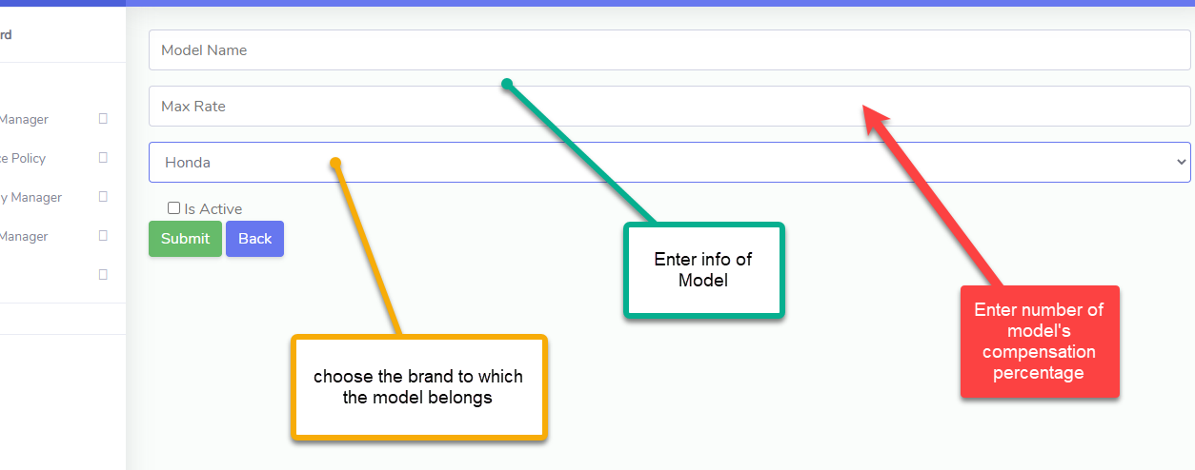

1. **Insurance Buy**

* **Select Insurance Plan:**

You must be logged in to perform this function

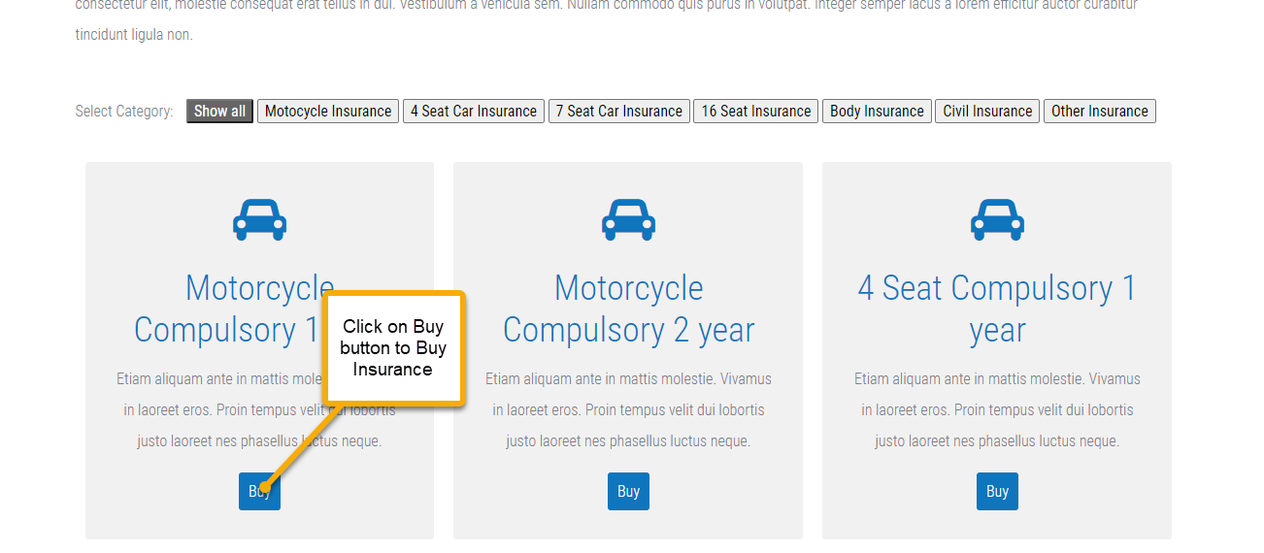

If you are not logged in, when you choose Buy, you will be redirected to the Login Page to log in



* **Buy Insurance:**

After logging in, you can now buy insurance, click the corresponding Buy button on each insurance package, an information input interface will appear to buy insurance.



The customer name and policy name will be populated according to your account and the insurance plan you choose. Date types will be filled in automatically based on system date and policy duration. Customers only need to fill in the information in the yellow circle. Total Payment represents the price of the insurance, calculated based on the insurance plan.

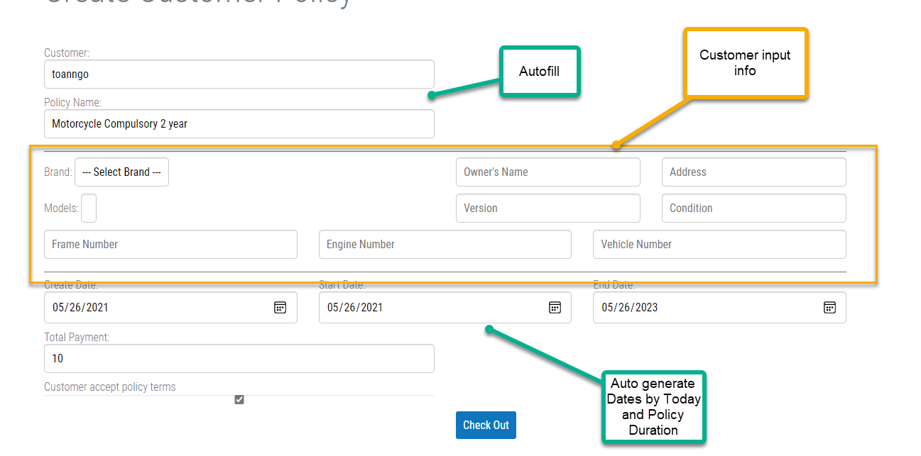

Please check the accept policy term then click Check Out to initiate payment

* **Payment:**

After click to Check Out Button, you will go to Check Out Page

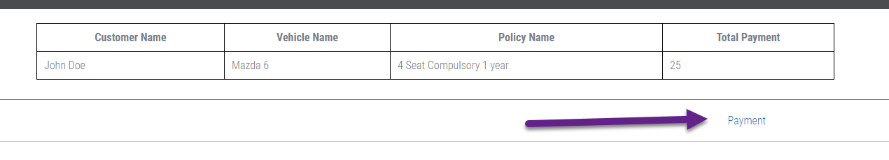

Check if the information is correct, if it is correct then click on Payment. You will be redirected to Paypal to payment. Enter your Paypal Account to pay

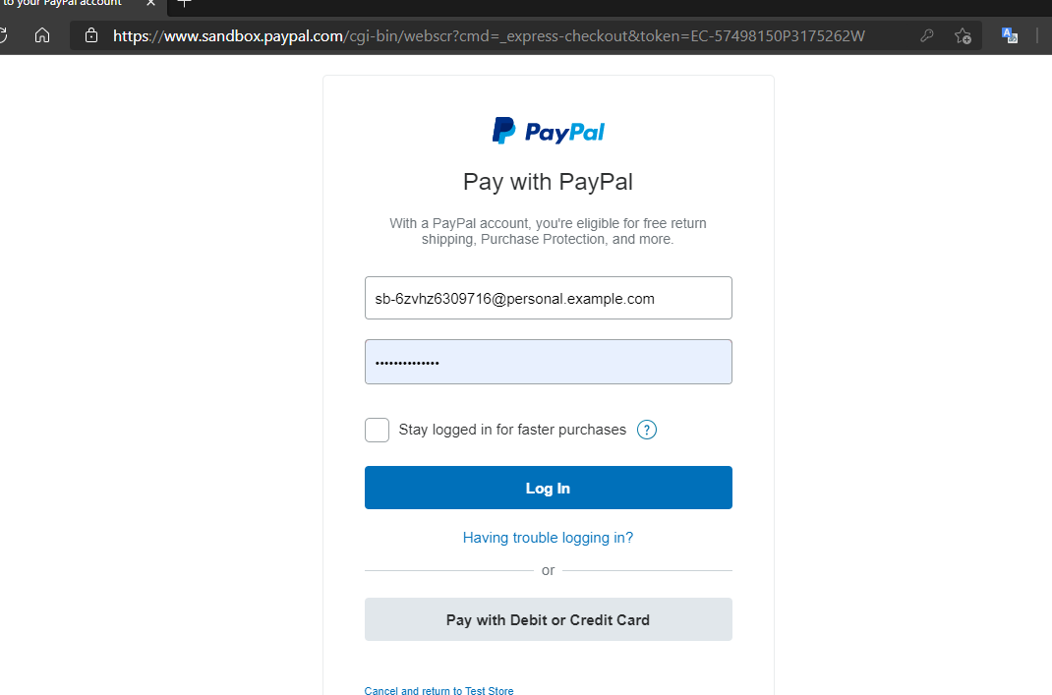

You will see insurance plan name and price on Product Detail of Paypal checkout

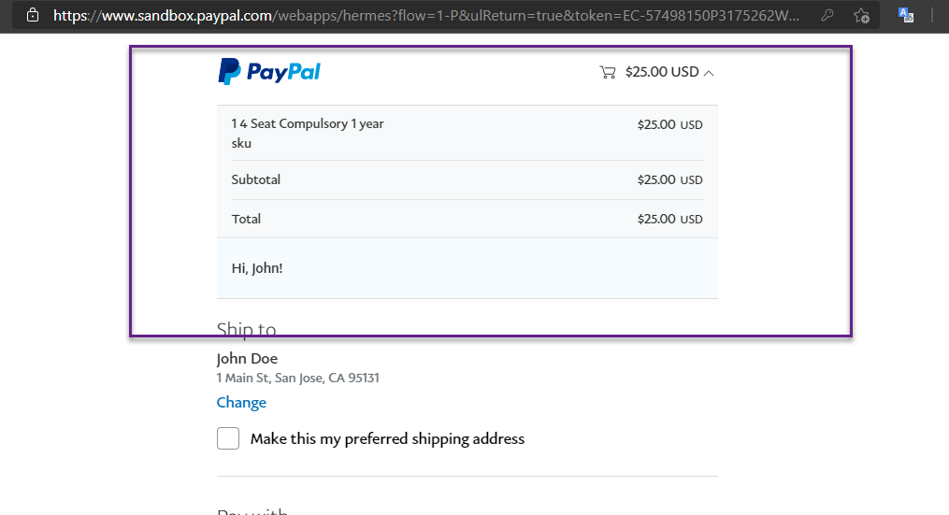

Check information and click to Continue to Payment

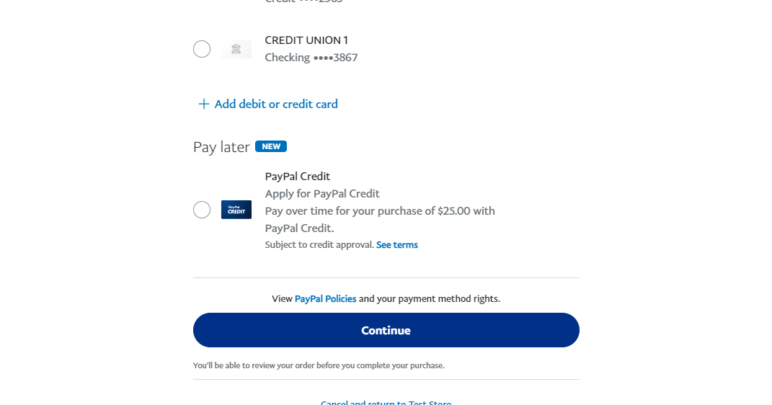

If the payment is successful, you will return to the page with the message "Successful payment"

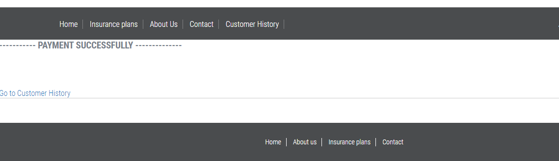

If the payment fails, you will return to the page with the message "Payment failed"

* **See History:**

If you want to get information about the order you just paid, go to Customer History

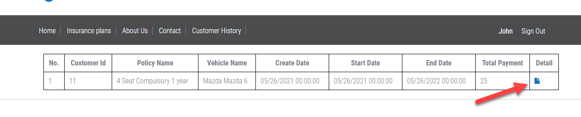

click on icon to see Detail

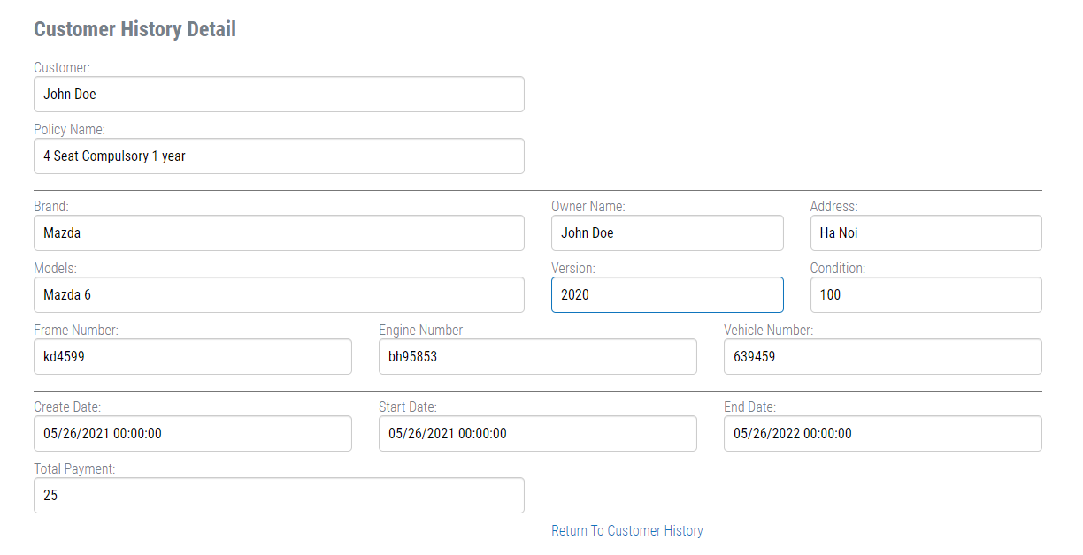

1. **Customer Policy Manage**

* **Policy Type:**

Click on Insurance Policy Tab and select Policy type to go to Policy Manage

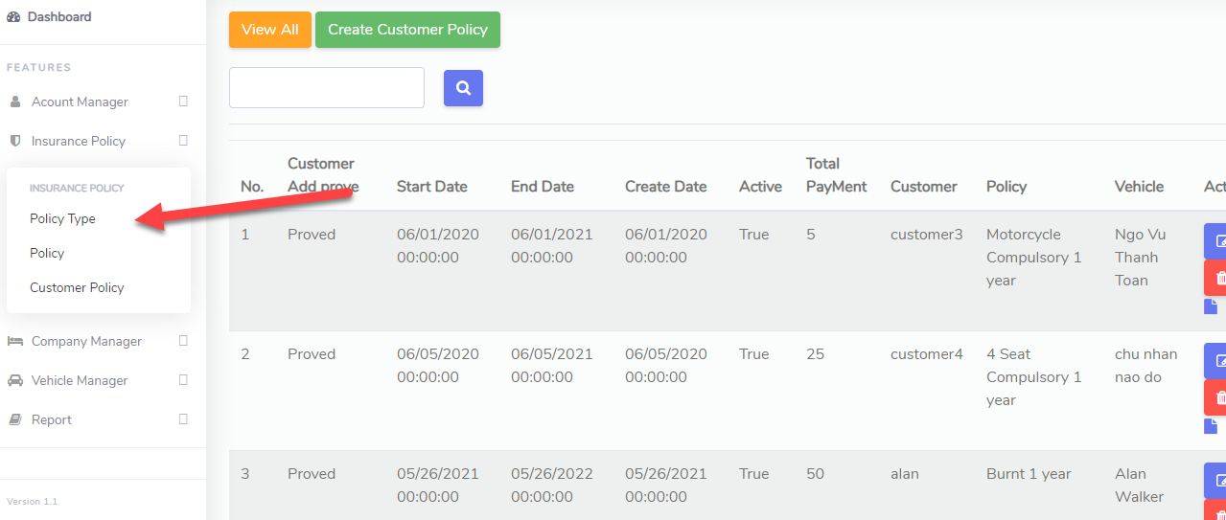

Click View All to view all Policy Type, click edit to edit Policy Type info, delete to delete Policy Type

Click on Create Policy Type to create new Policy Type

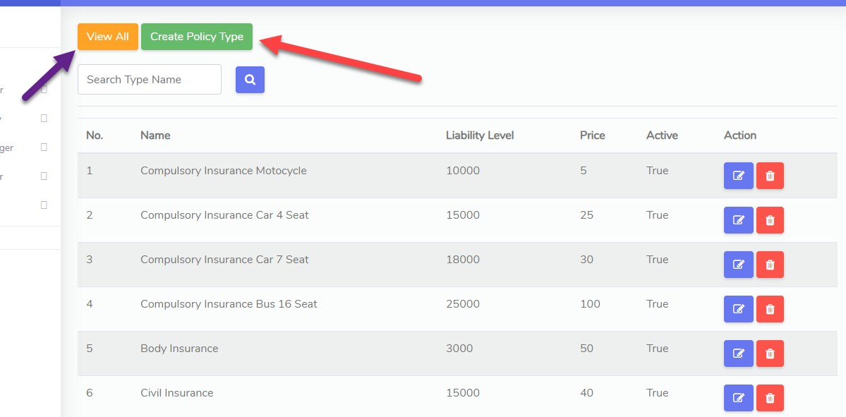

Enter Policy Type Name, Liability Level to set the highest amount of compensation for the policy type (number), price to set the price of Policy Type. Check to Active and click Submit

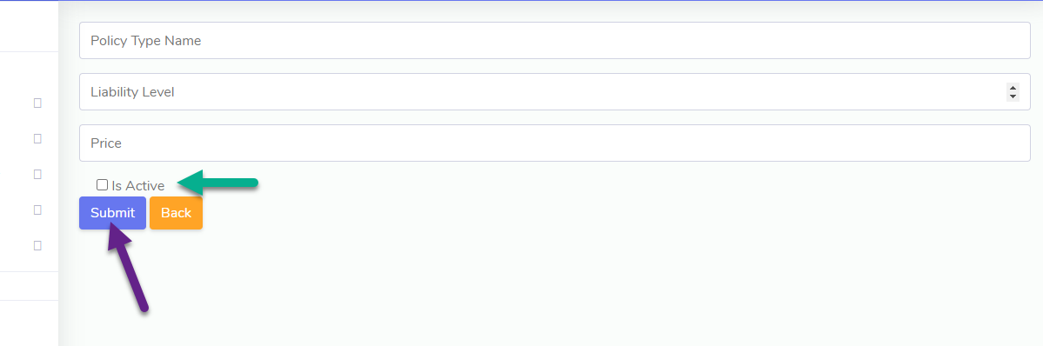

* **Policy**

Select Policy on Insurance Policy Tab to go to Policy Manage Page

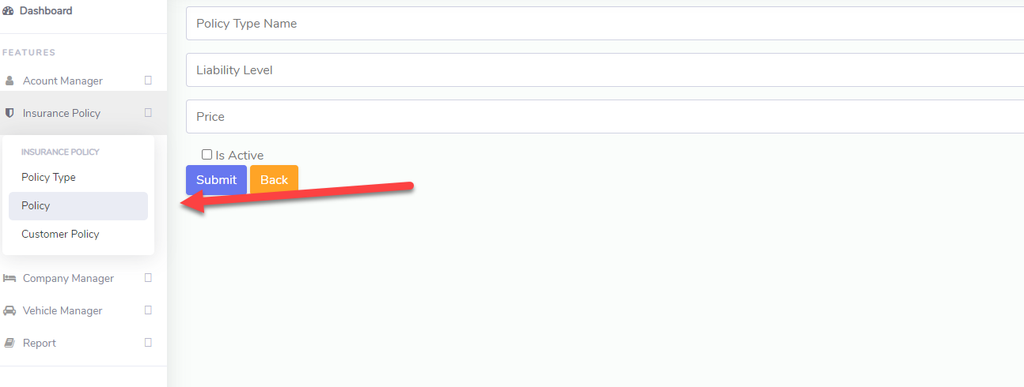

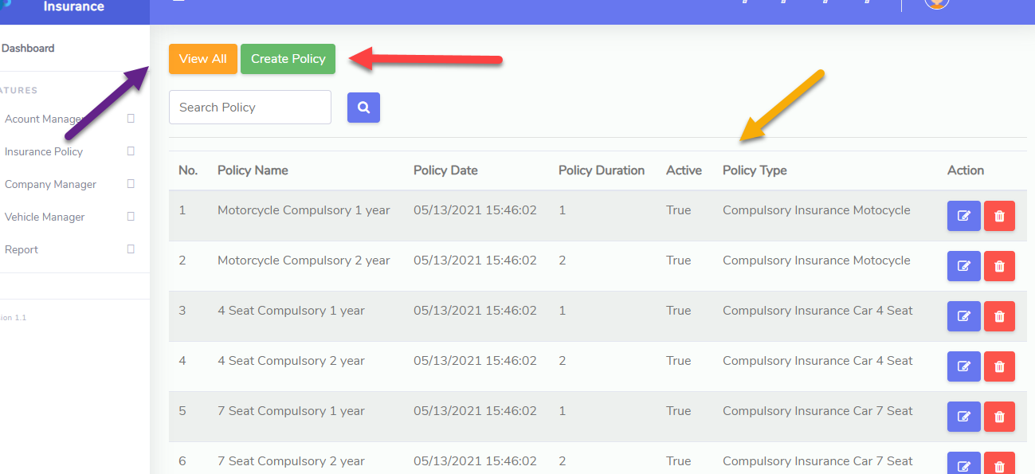

Click View All to View All Policy, Click Create Policy to create new Policy

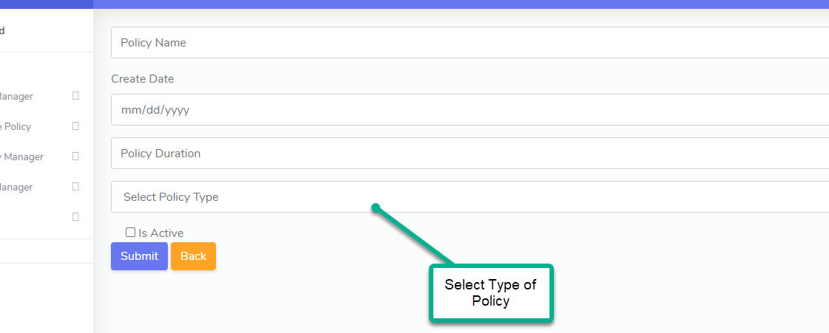

Enter Policy Name (will display on Insurance Plan Page), create date, policy duration (ex: 1, 2 corresponding 1 year, 2 year), select type of Policy, check to active and click submit to create new

* **Customer Policy**

Click Customer Policy on Insurance Policy Tab

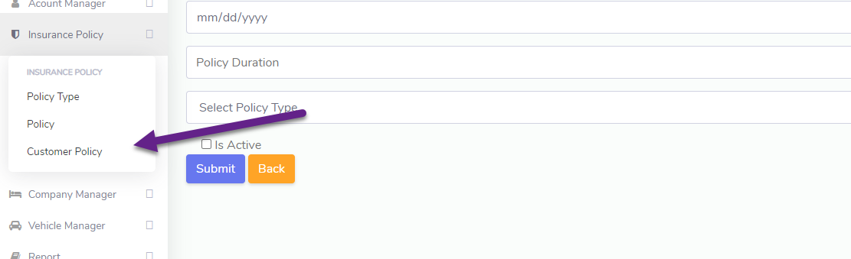

Click View All to view all Customer Policy, click Edit icon to edit, click Delete icon to delete Customer Policy , click icon in image below to create bill for Customer Policy

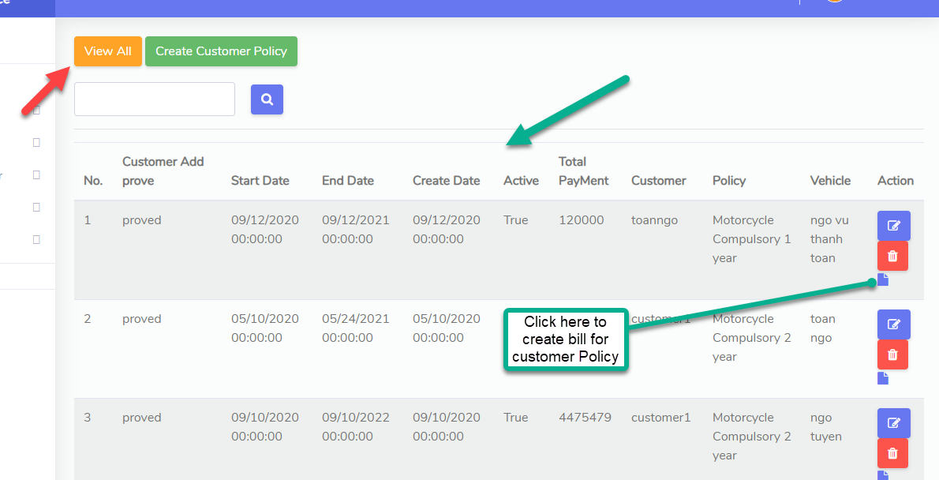

To Filter Customer Policy By Date, select Start Date and End Date and click to Confirm to filter

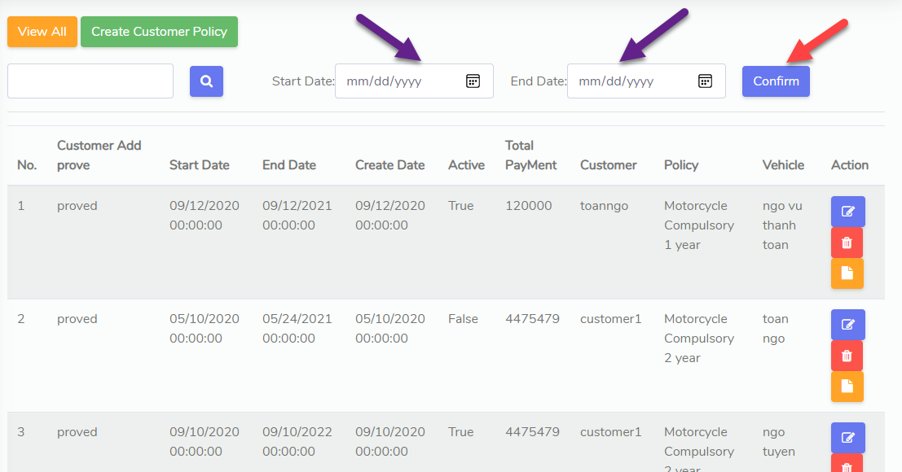

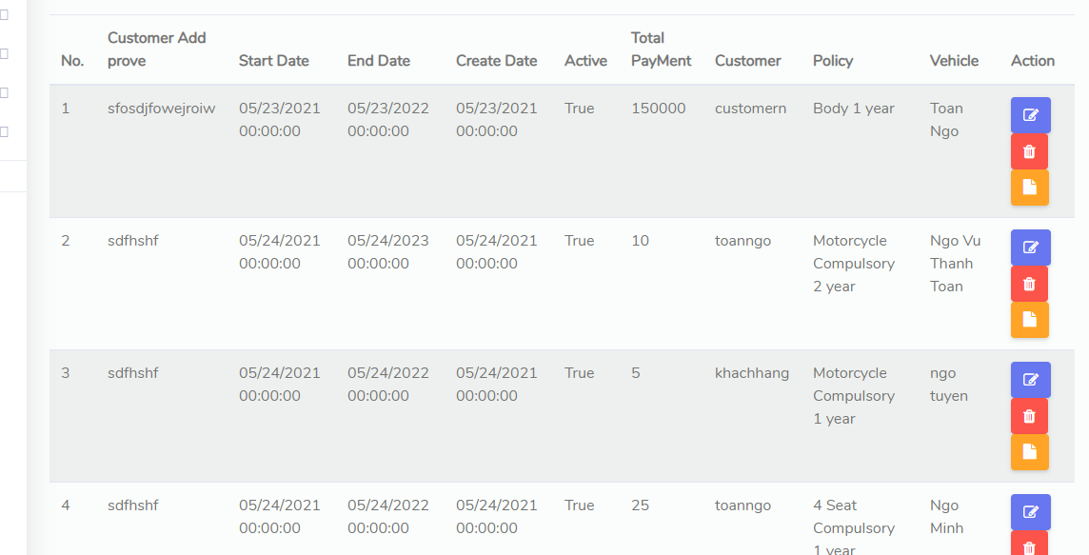

1. **Customer Policy Bill**

* Select Customer Billing Info to go to Customer Billing Info manage

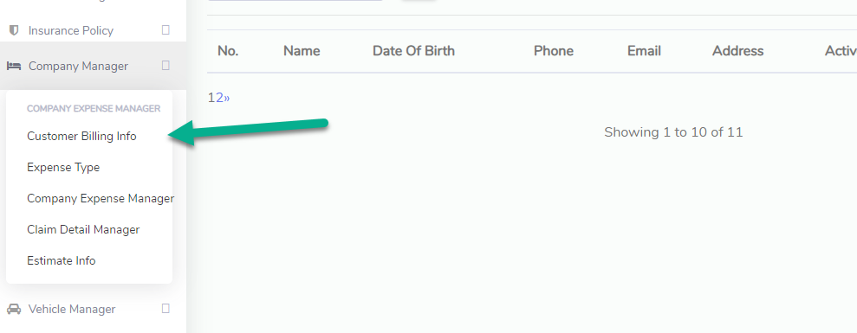

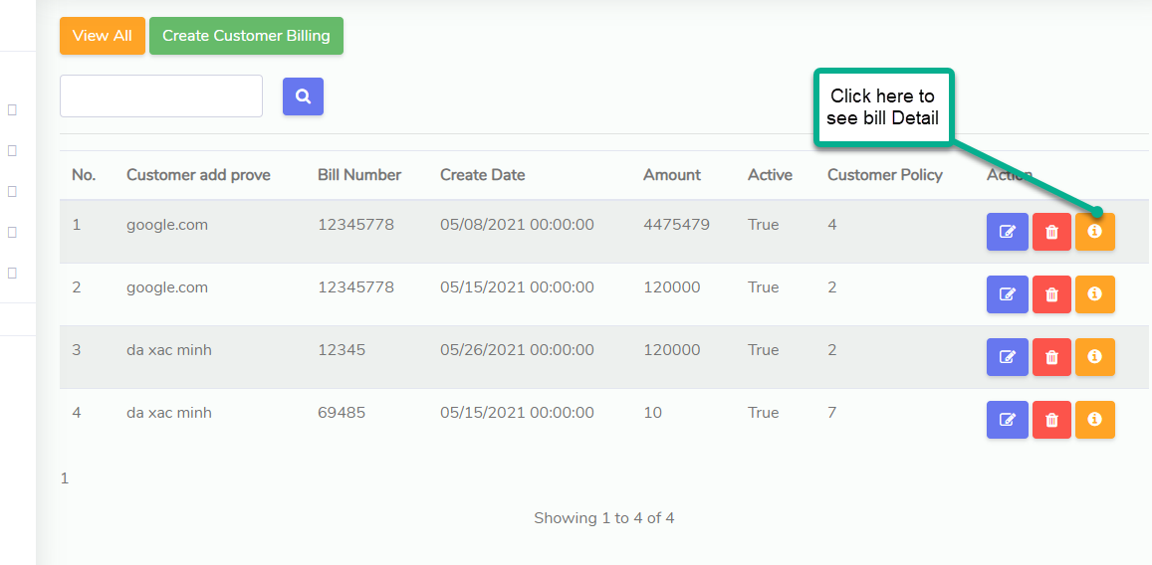

Click on Icon on above image to see detail of bill

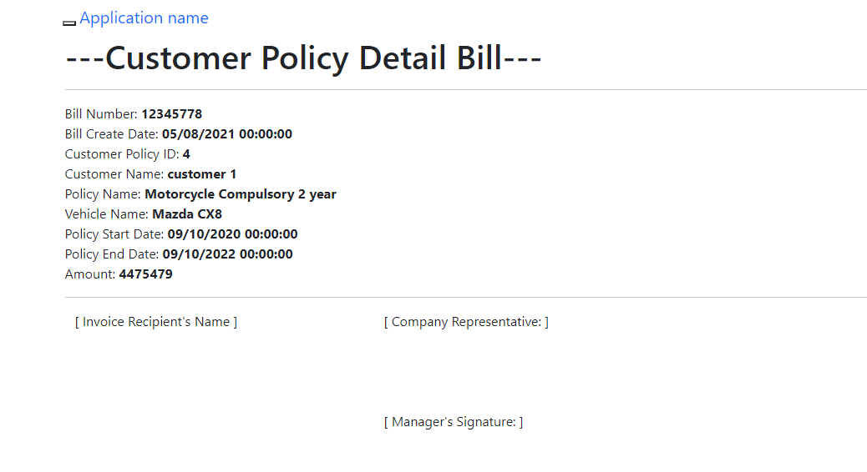

if you want to Print or Save Bill as PDF then click by Button

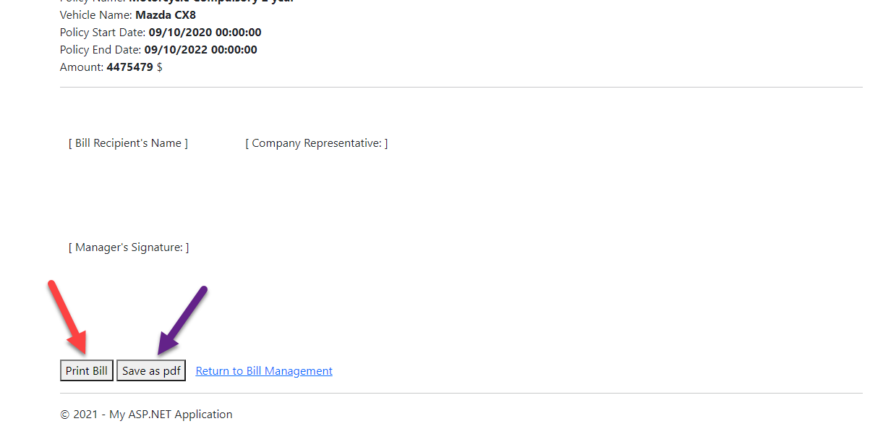

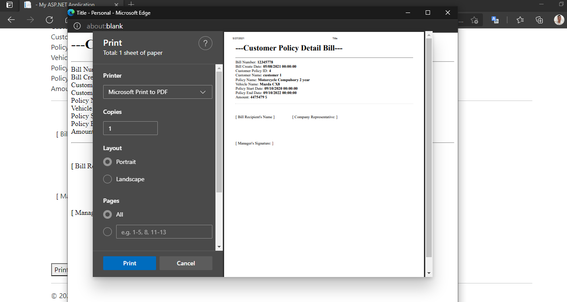

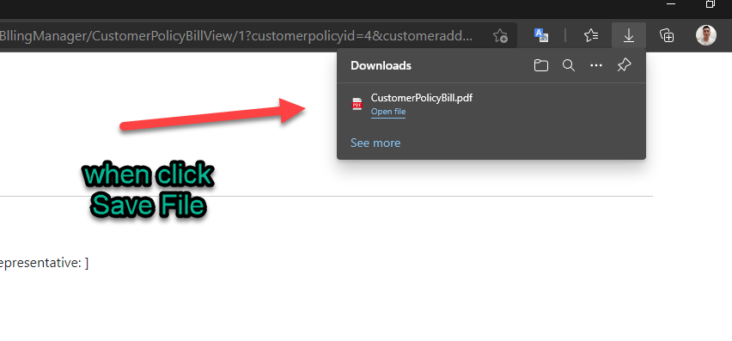

To filter Bill By Date, Select Start Date and End Date and click confirm to filter

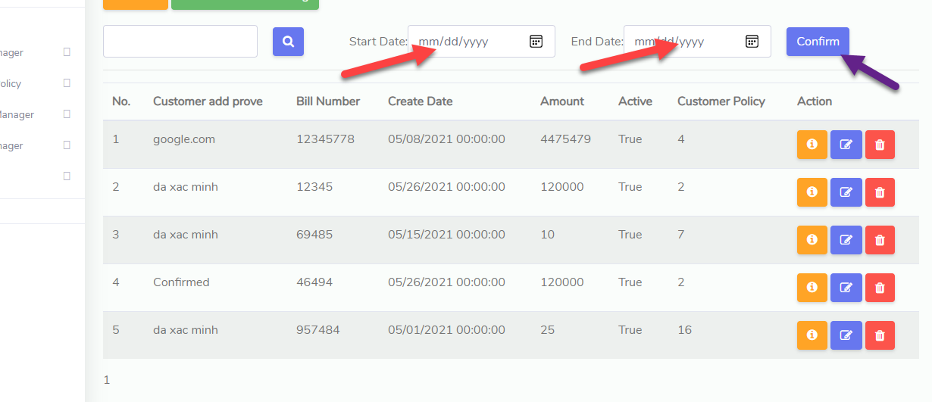

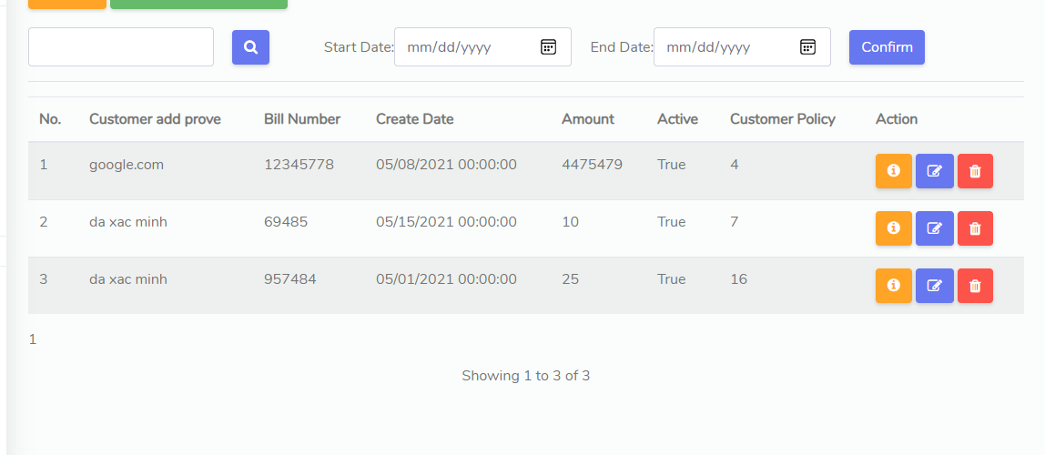

* **Create Bill for Customer Policy:**

Select Icon on Customer Policy Manage to create bill



Enter Customer Add Proves (ex: confirmed), Bill Number, Create Date, check to Active and click Submit to create new Bill

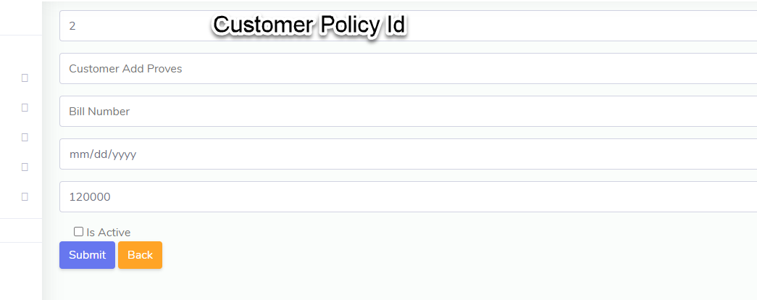

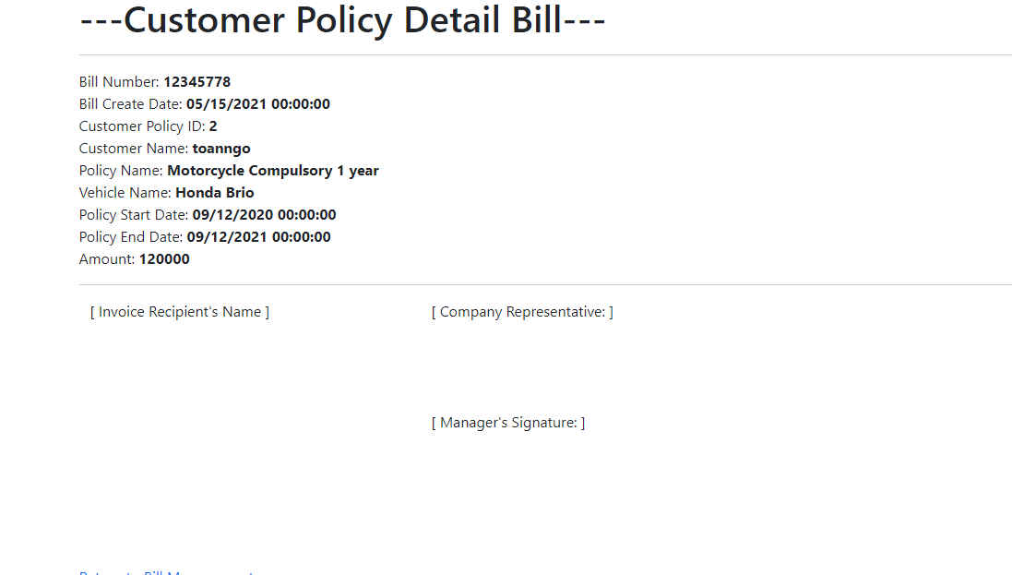

if you want to Print or Save Bill as PDF then click by Button







1. **Report**

* **Insurance Monthly**

Select Insurance Monthly on Report tab to go to Insurance Monthly Report

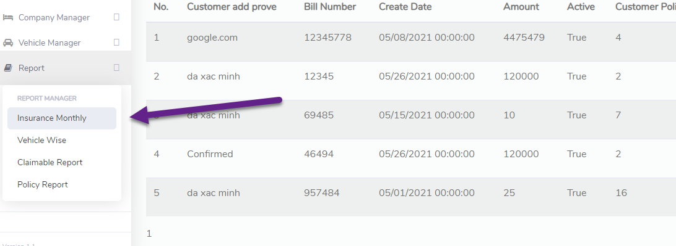

Initial results are of full time

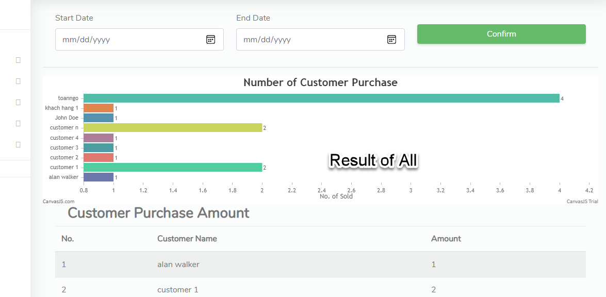

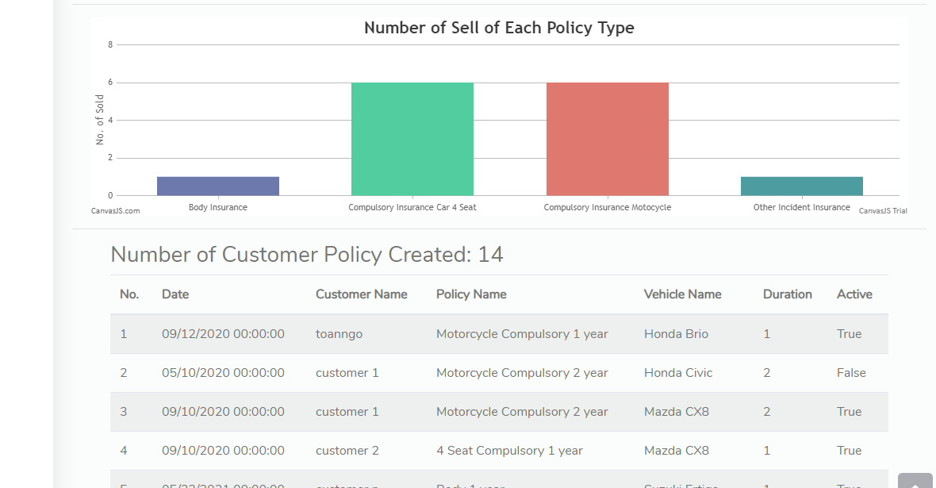

Select Start Date and End Date to get result in time range

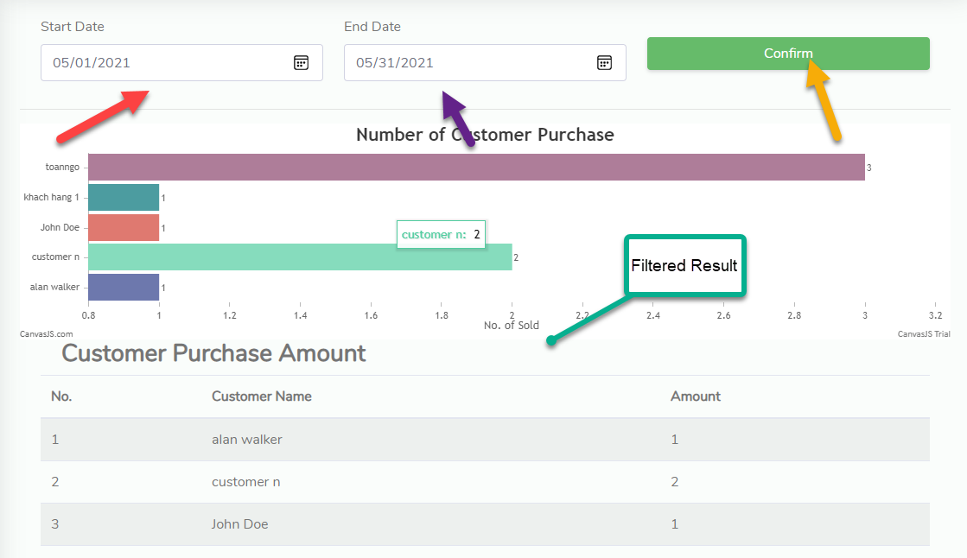

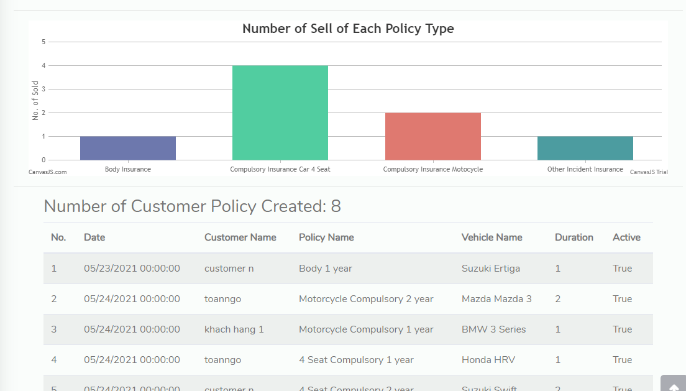

If you want to print report click Print Button

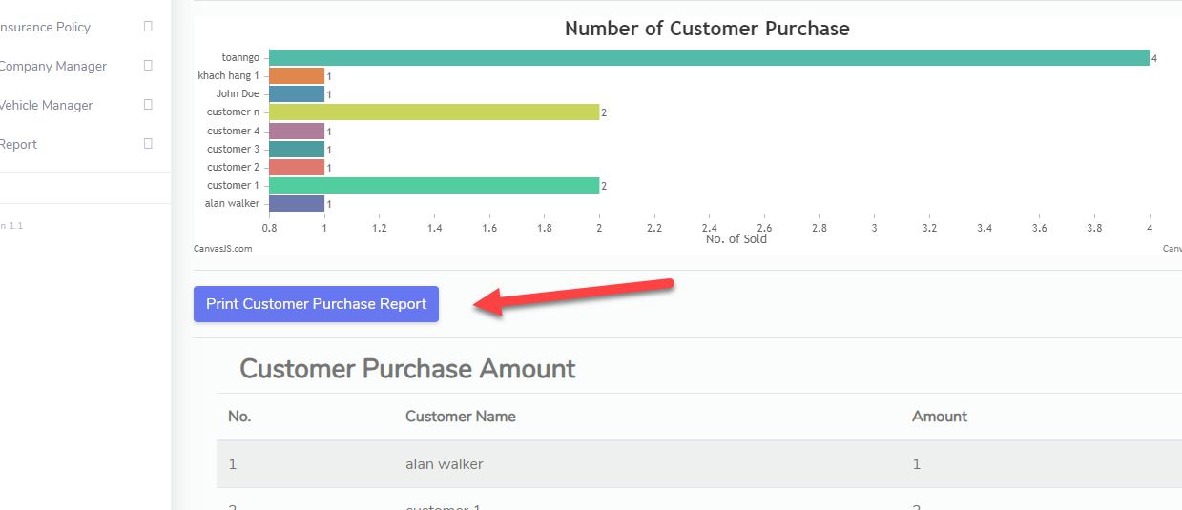

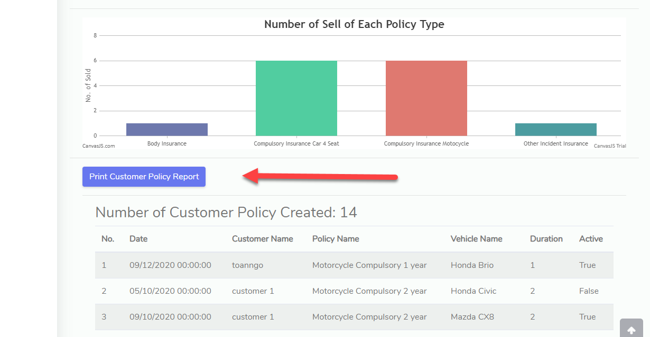

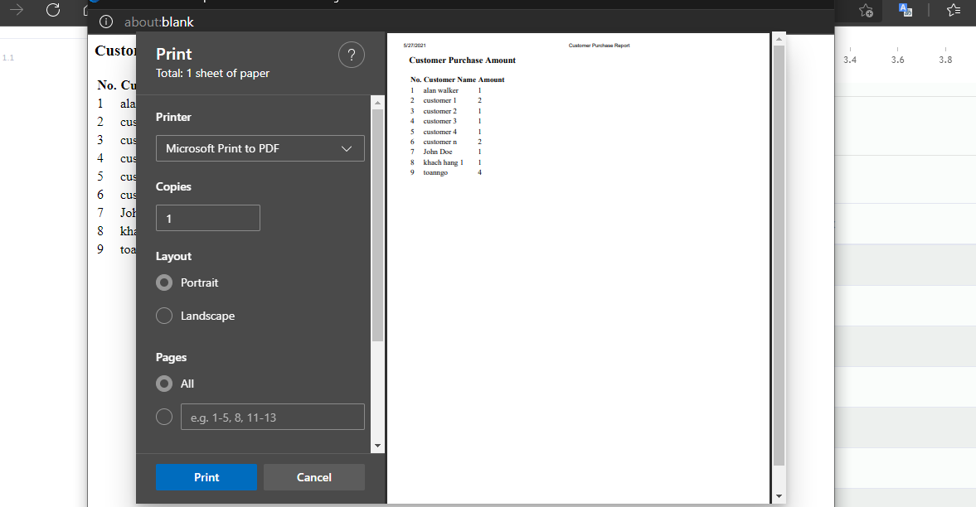

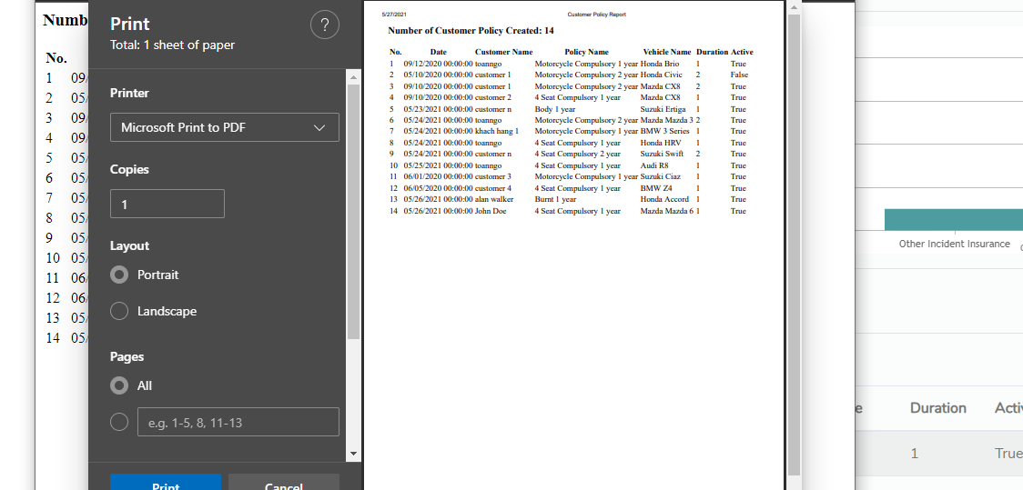

* **Vehicle Wise**

Select Vehicle Wise on Report to go to Vehicle Wise Report

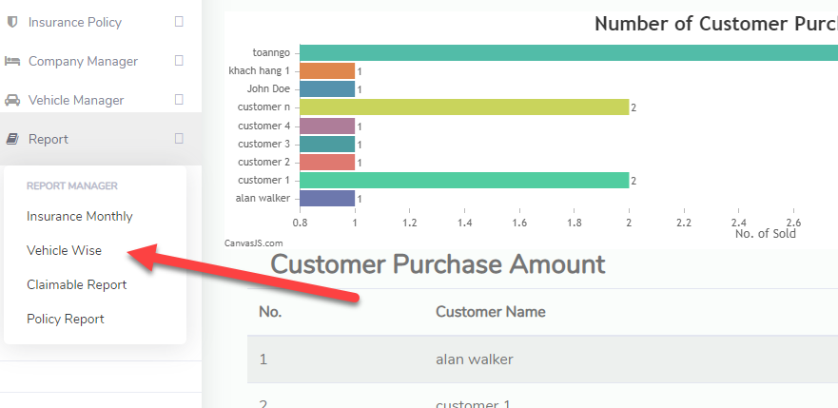

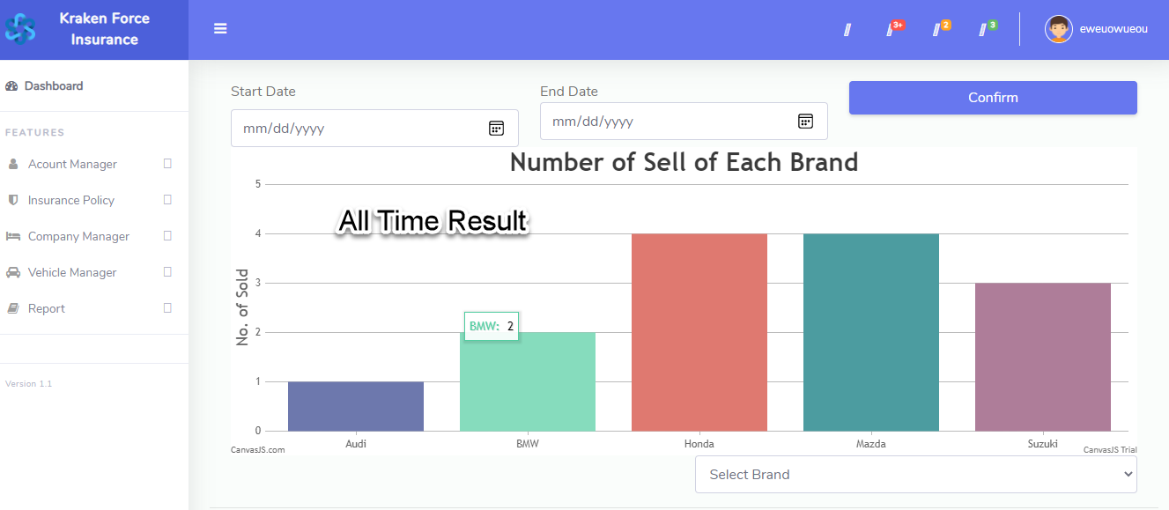

Select Start Date, End Date and click Confirm to filter Result, chart will generate

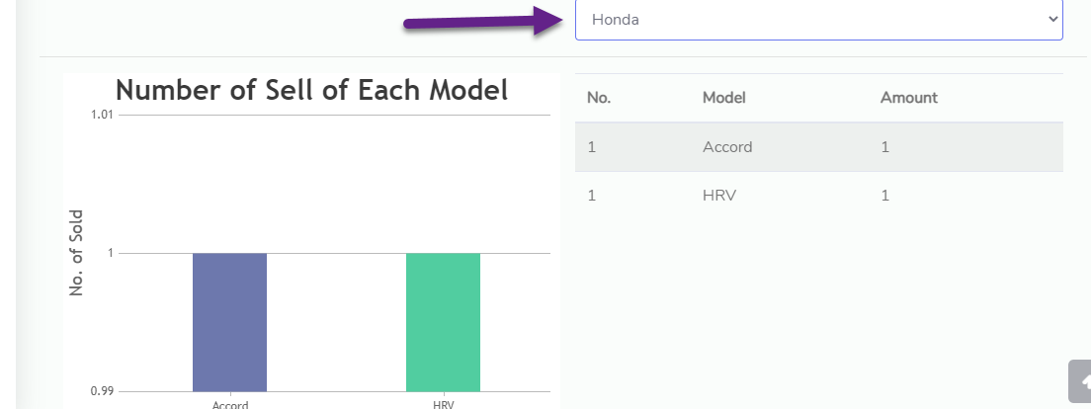

Select Brand name and you will get the number of sales for each model of the brand

* **Claimable Report**

Click Claimable Report to go to Claim Report Page

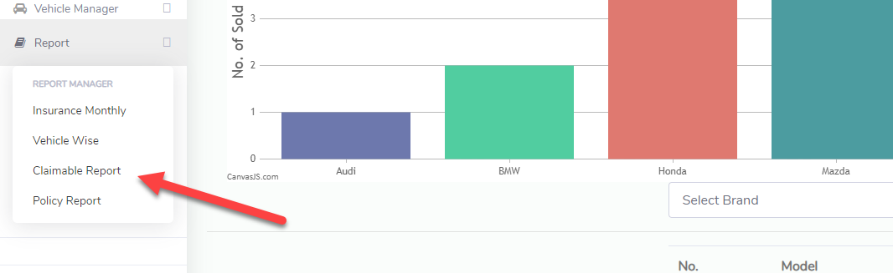

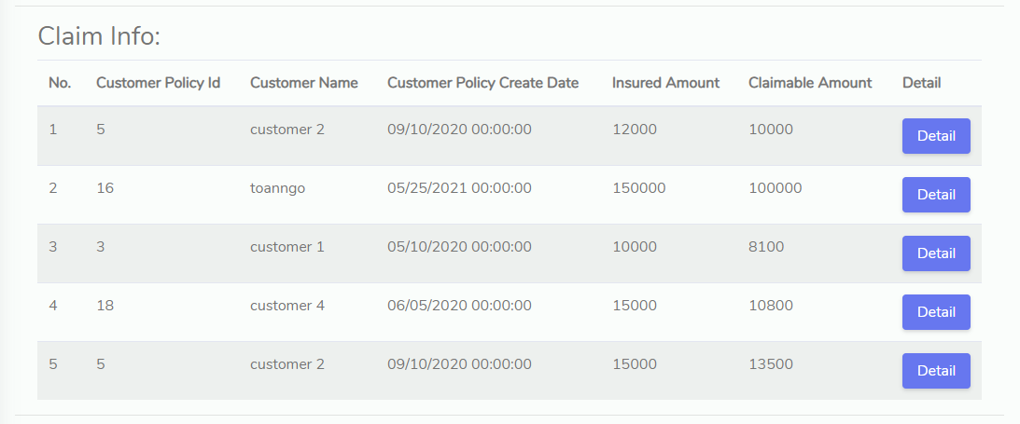

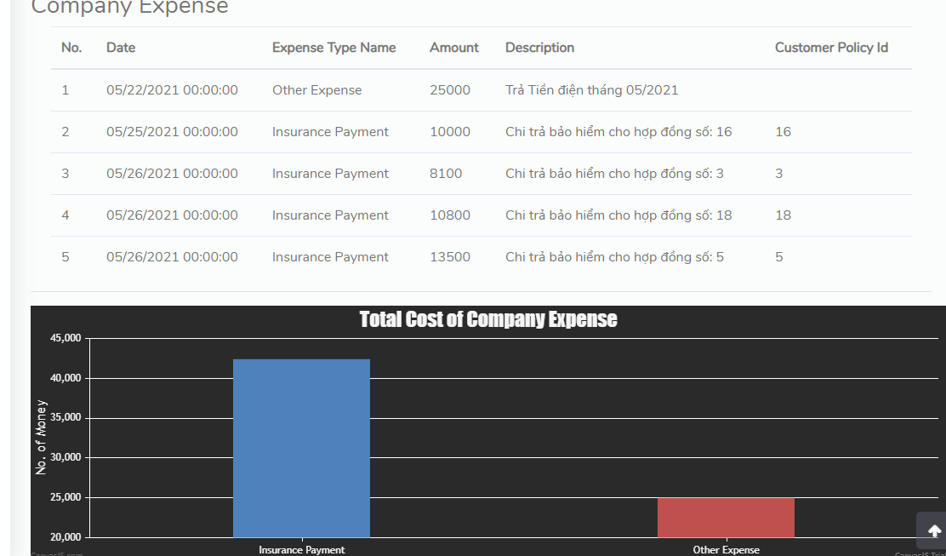

Select Start Date and End Date and click confirm to filter result

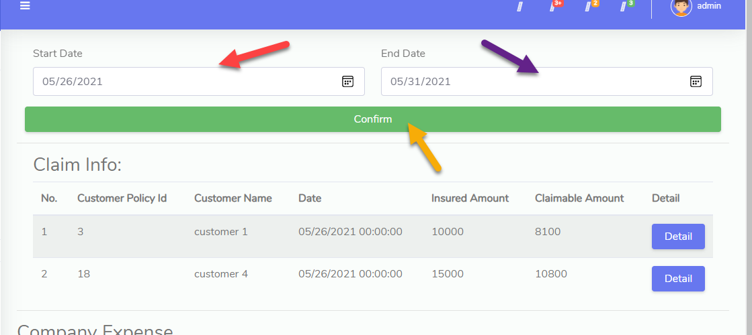

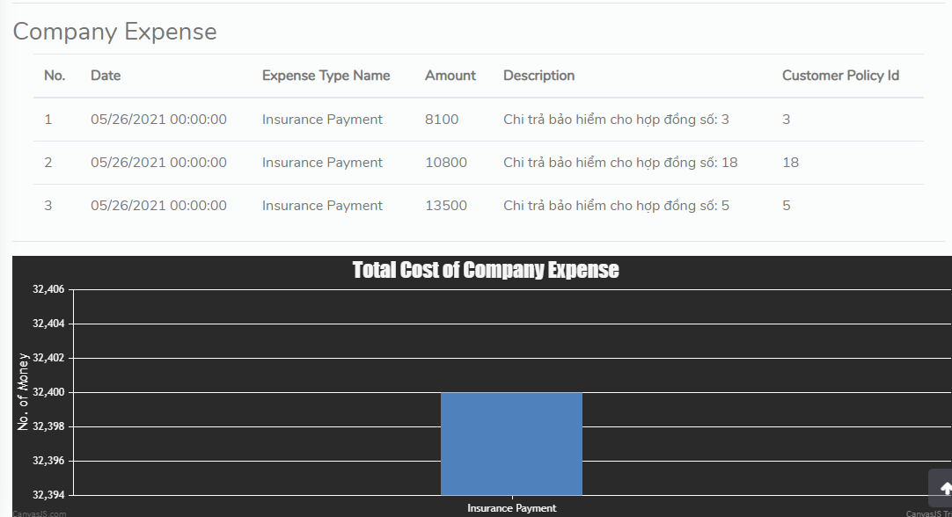

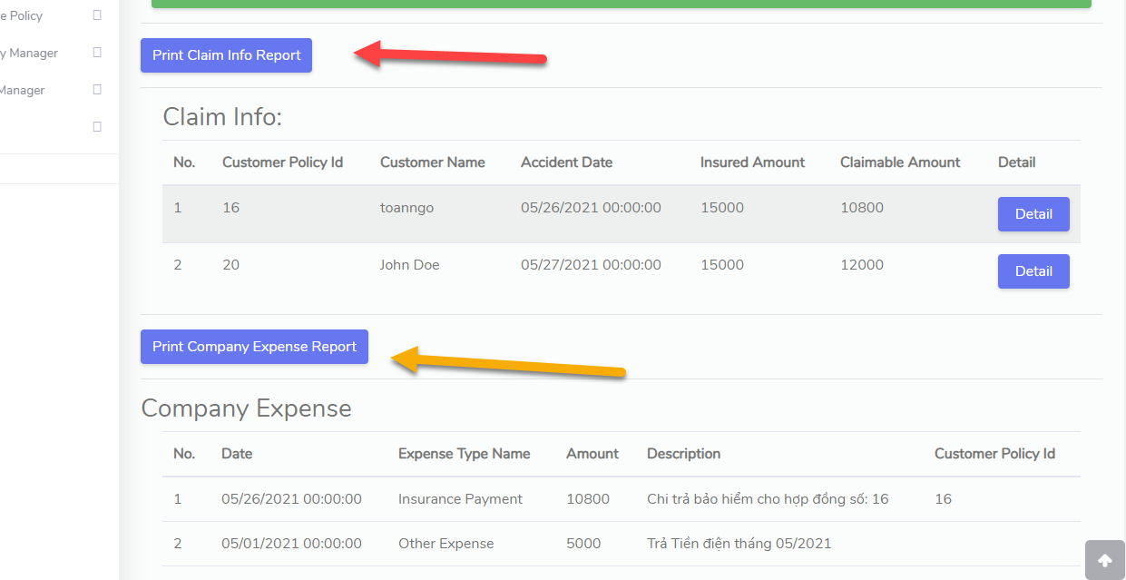

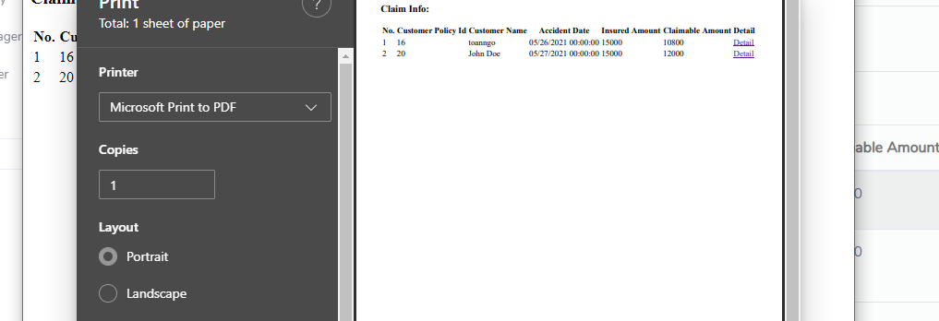

* **Policy Report**

Select Policy Report on Report to go to Policy due and lapse report

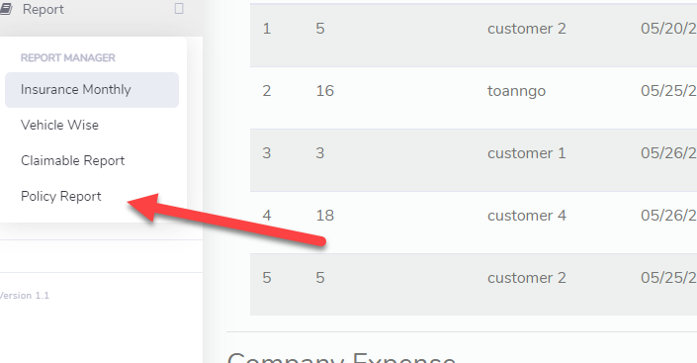

If the contract expiration date is within the next 1 month from today, it will be displayed in Policy Due Renewals

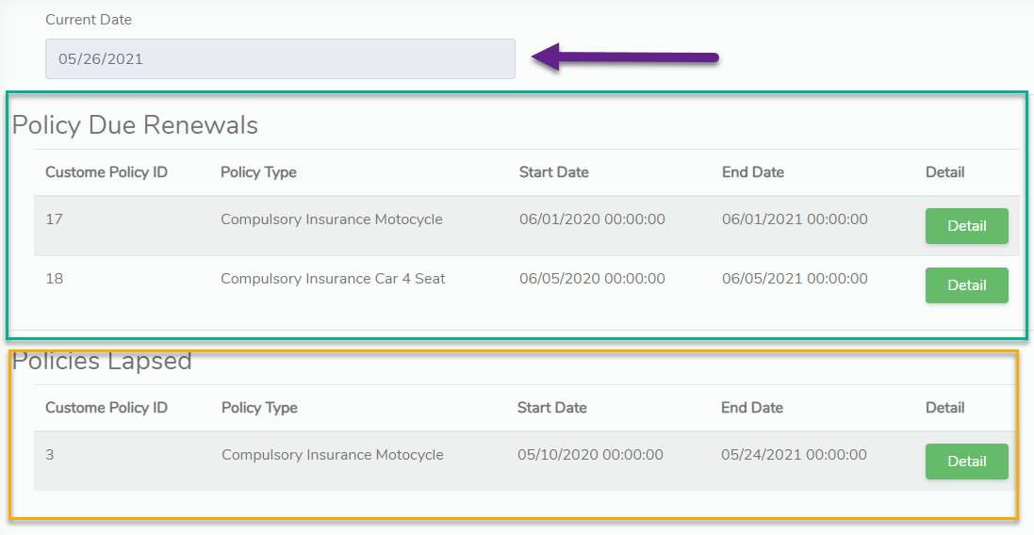

If the policy expiration date is less than today it means the Customer policy is expired and is displayed in the Policy Lapsed table

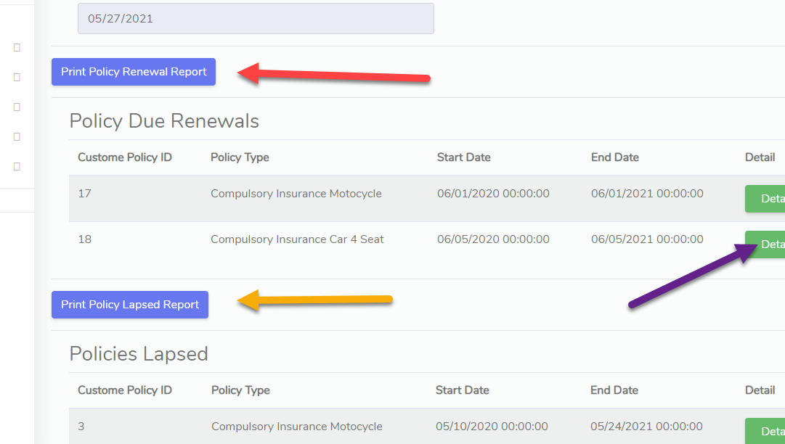

Click Detail button to see Detail of Customer Policy

1. **Company Expense**

* **Expense Type:**

Select Expense Type on Company Manager to go to Expense Type Manage

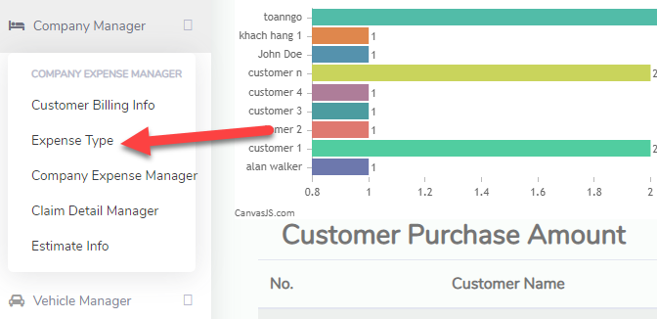

Click View All to show all type, click Create Expense type to create new Expense type

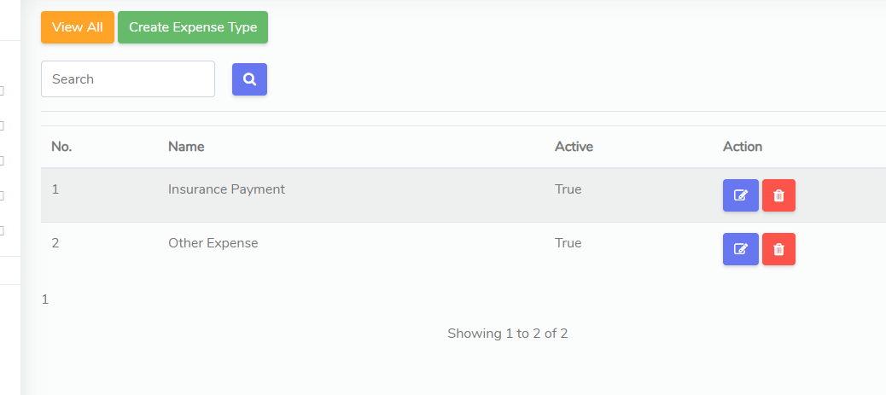

Enter Expense type name, check to active and click Submit to Add

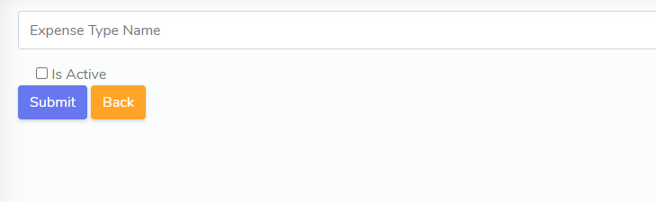

* **Company Expense Manage:**

Select Company Expense Manage to go to Page

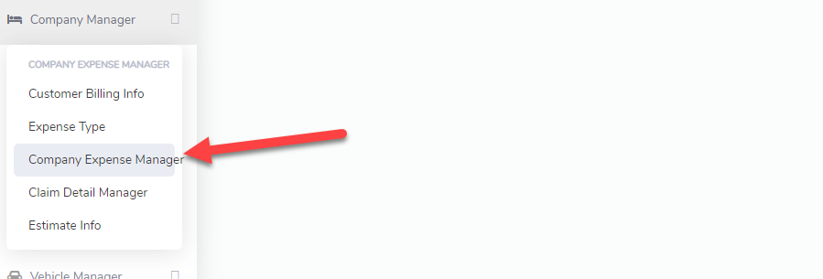

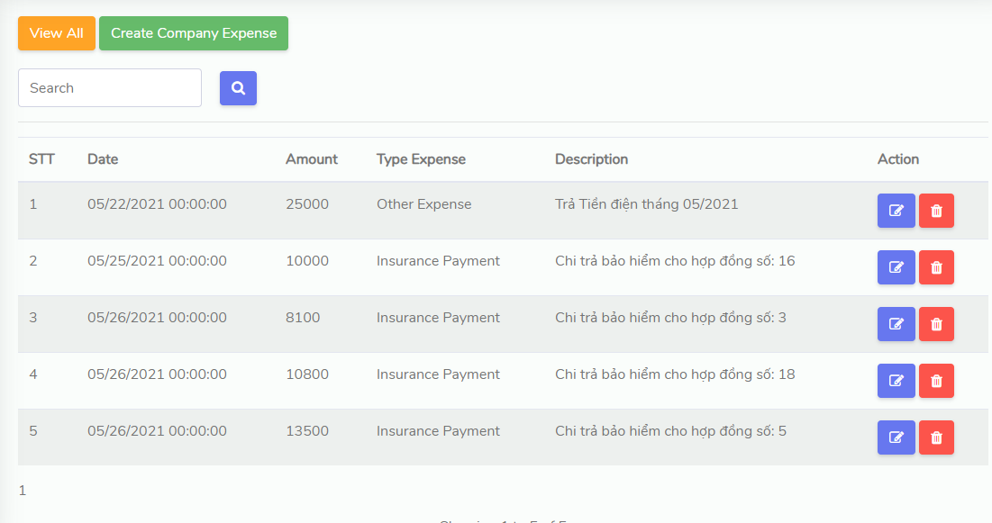

To Filter Expense By Date, select Start Date and End Date and click Confirm

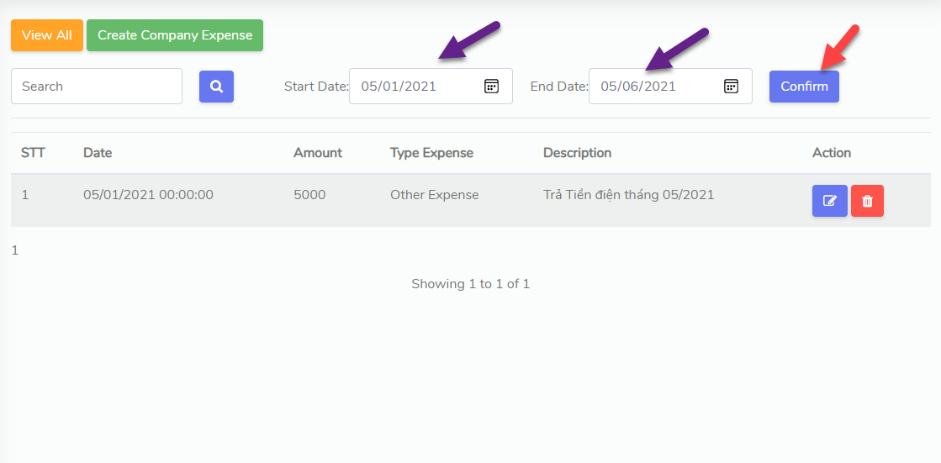

Click Create Company Expense to create other expense because Insurance Payment will be generated by Create Customer Policy Claim.

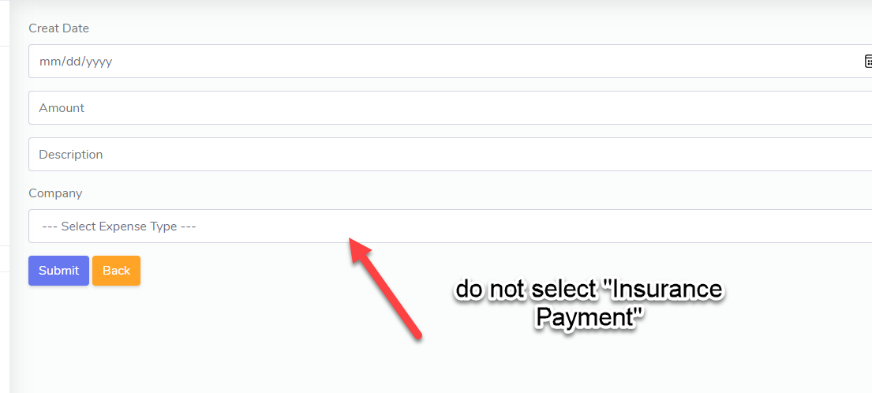

click Submit to create Expense

1. **Claim Detail**

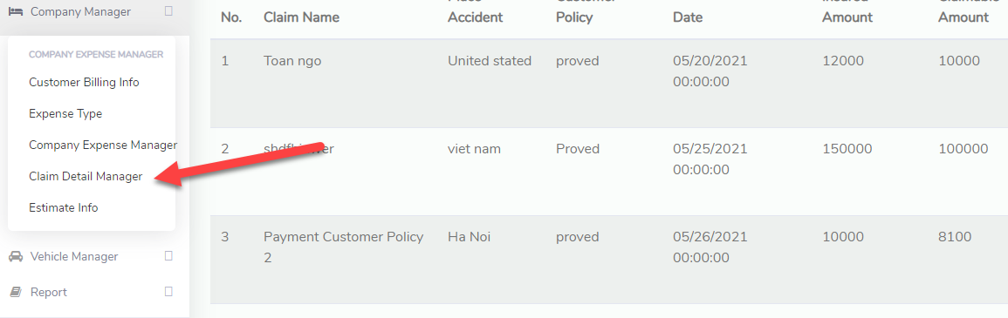

Select Claim Detail Manager on Company Manager to go to Page

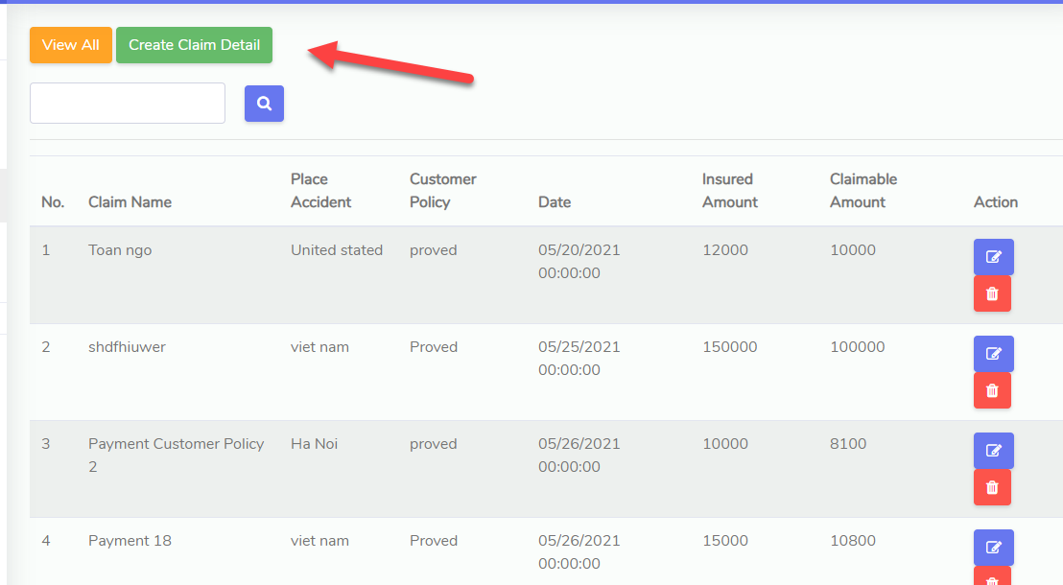

To Filter Claim by Date, select StartDate and EndDate to filter

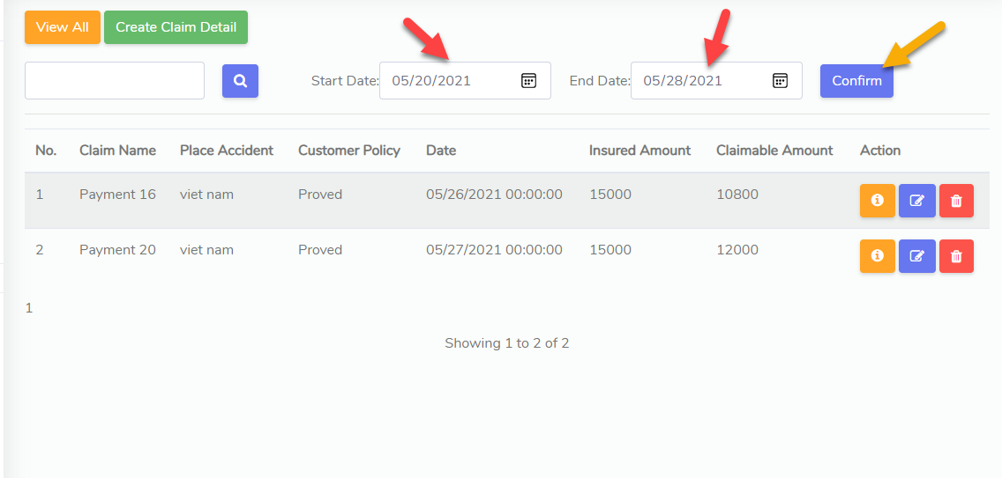

Click Create Claim Detail to create new Claim Detail

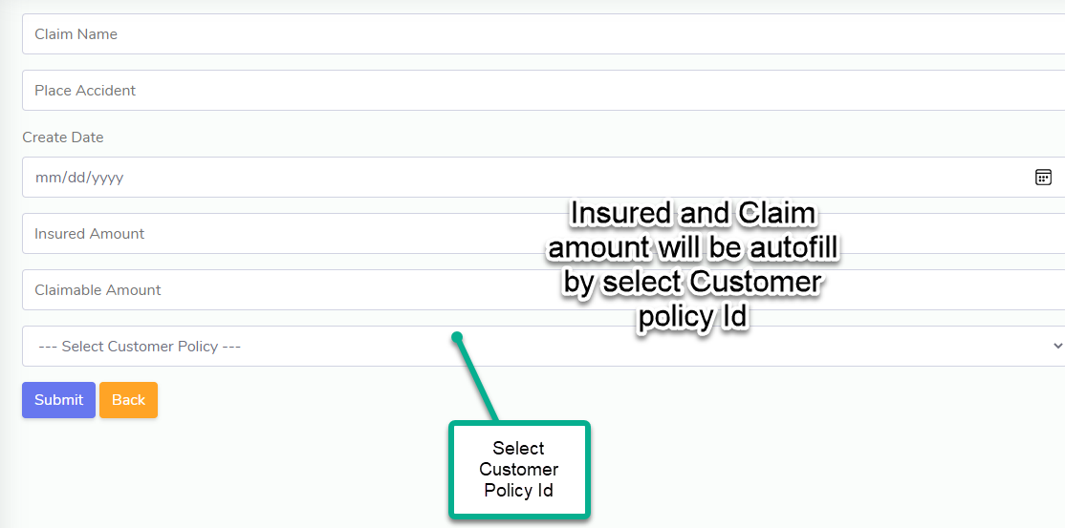

After click Submit, you will get Claim Detail Bill and it will add a record to Company Expense with type Insurance Payment

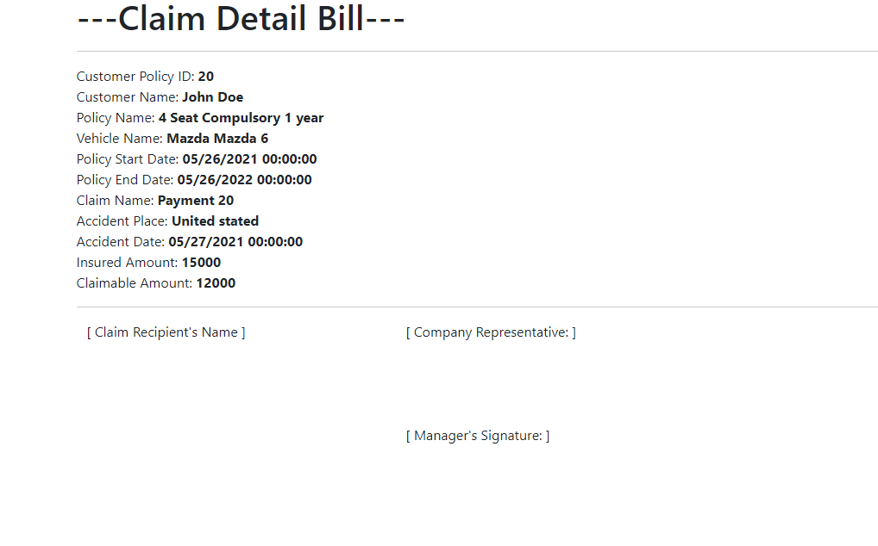

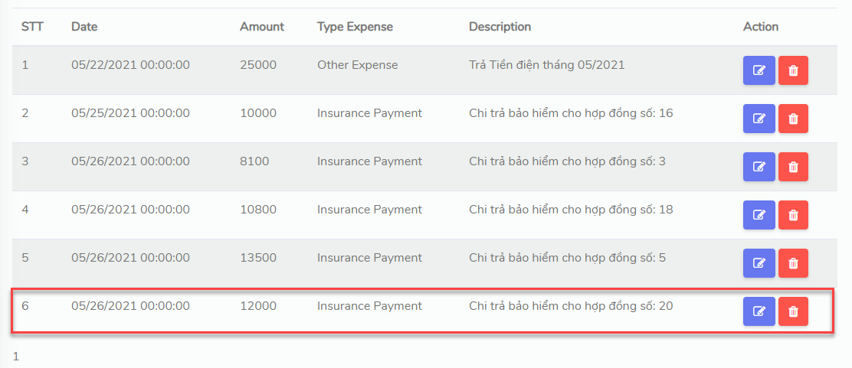

if you want to print Bill, click Print or Save File

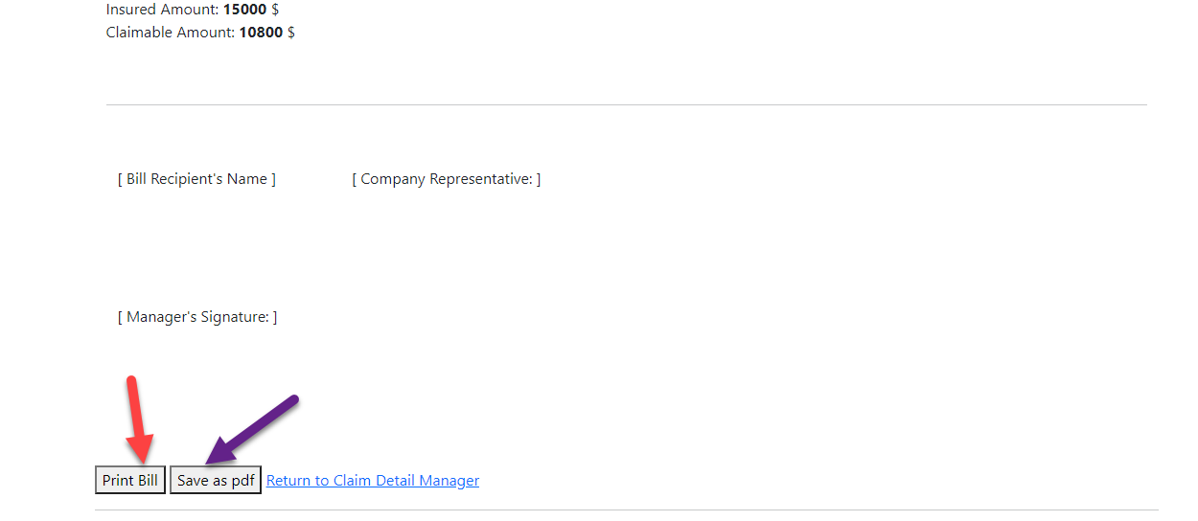

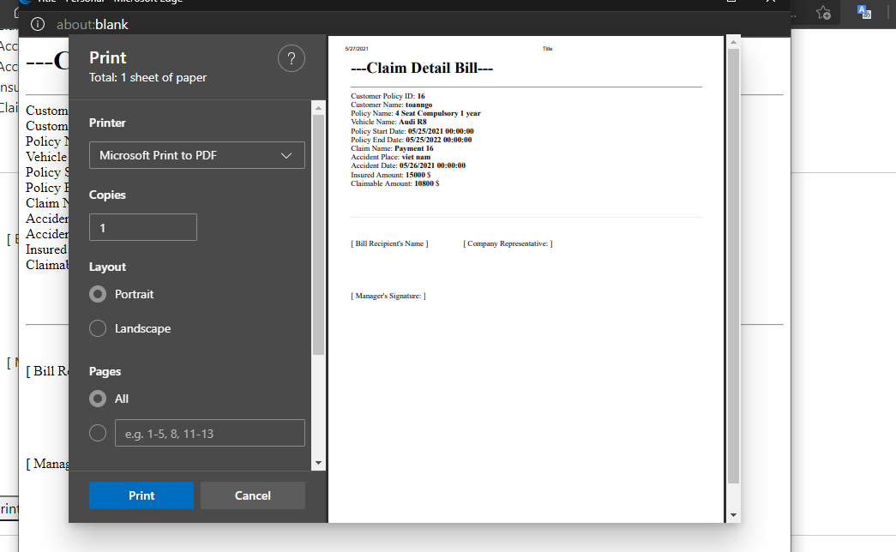

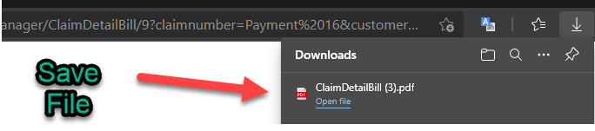

Click on yellow icon on Claim Detail manager to see bill of Claim Detail

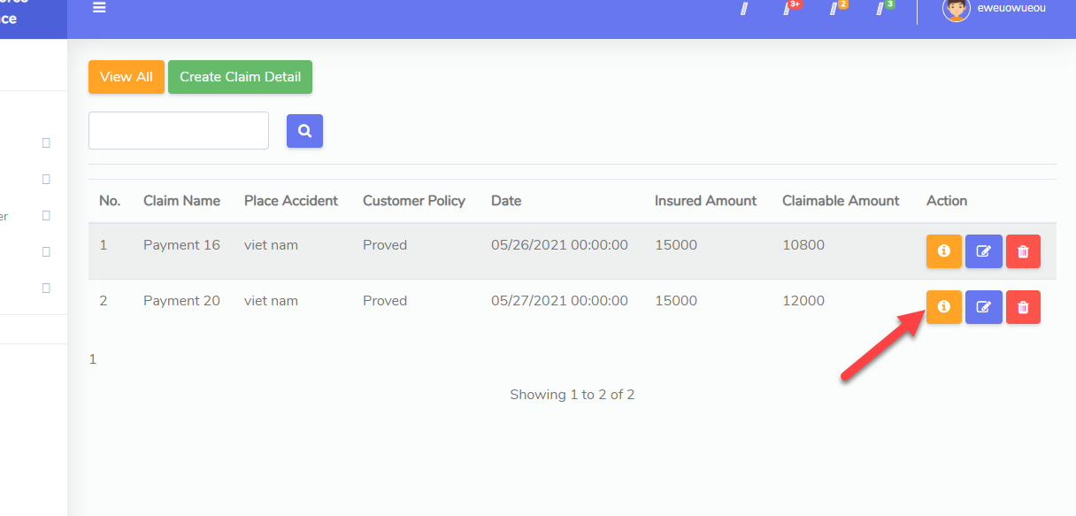

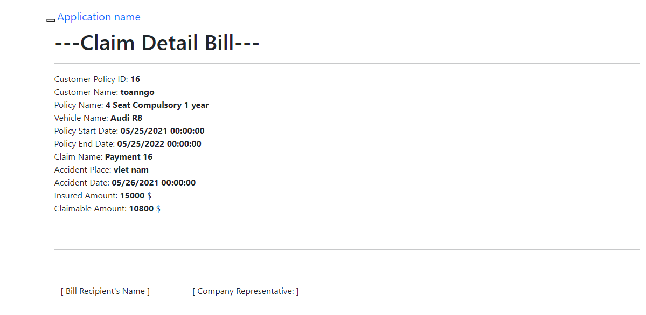

**VII . Development Guide**

- Github:

<https://github.com/ToanNgo2709/VehicleInsurance_Sem_3_Project>

* N-Tier Layer Layer Architecture:

The project consists of 4 main layers:

1. **VehicleInsuranceSem3 Layer**:

The instance layer for WebApplication, used to display the user interface and manage the website's controllers and resources

1. **VehicleInsuranceSem3.DAL**:

Used to manage Model Database Entities, managed with Entity Framework.

1. **VehicleInsuranceSem3.BLL**:

Used to manage ViewModels and DAO classes are used to get data to ViewModels without directly touching the Models at the DAL layer.

1. **VehicleInsurenceSem3.Utilities**:

Used to contain classes with utility functions such as encrypting passwords, uploading images, and some other utilities so that other layers can call when needed.

* Sample Database:

[Vehicle_Insurance_Sample_Database](https://drive.google.com/file/d/1gtvqisk7Nm6N25JeT9RlXnGQfLRmIzT6/view?usp=sharing)